**Nitte Menakshi Institute of Technology**

**Department of Information Science & Engineering**

**Java Lab Programs – Even Sem 2017**

**How do I write a simple "Hello World" program?**

To write a "Hello World" program follow these steps:

1. Start Eclipse.
2. Create a new Java Project:
   1. **File->New->Project**.
   2. Select "**Java**" in the category list.
   3. Select "**Java Project**" in the project list. Click "**Next**".
   4. Enter a project name into the **Project name** field, for example, "**HelloWorld**".
   5. Click "**Finish**"--It will ask you if you want the Java perspective to open. (You do.)
3. Create a new Java class:
   1. Click the "**Create a Java Class**" button in the toolbar. (This is the icon below "**Run**" and "**Window**" with a tooltip that says "New Java Class.")
   2. Enter "**HelloWorld**" into the **Name** field.
   3. Click the checkbox indicating that you would like Eclipse to create a "**public static void main(String[] args)**" method.
   4. Click "**Finish**".
4. A Java editor for **HelloWorld.java** will open. In the main method enter the following line.  
   **System.out.println("Hello World");**
5. Save using **ctrl-s**. This automatically compiles **HelloWorld.java**.
6. Click the "**Run**" button in the toolbar (looks like a little man running).
7. You will be prompted to create a Launch configuration. Select "**Java Application**" and click "**New**".
8. Click "**Run**" to run the Hello World program. The console will open and display "**Hello World**".



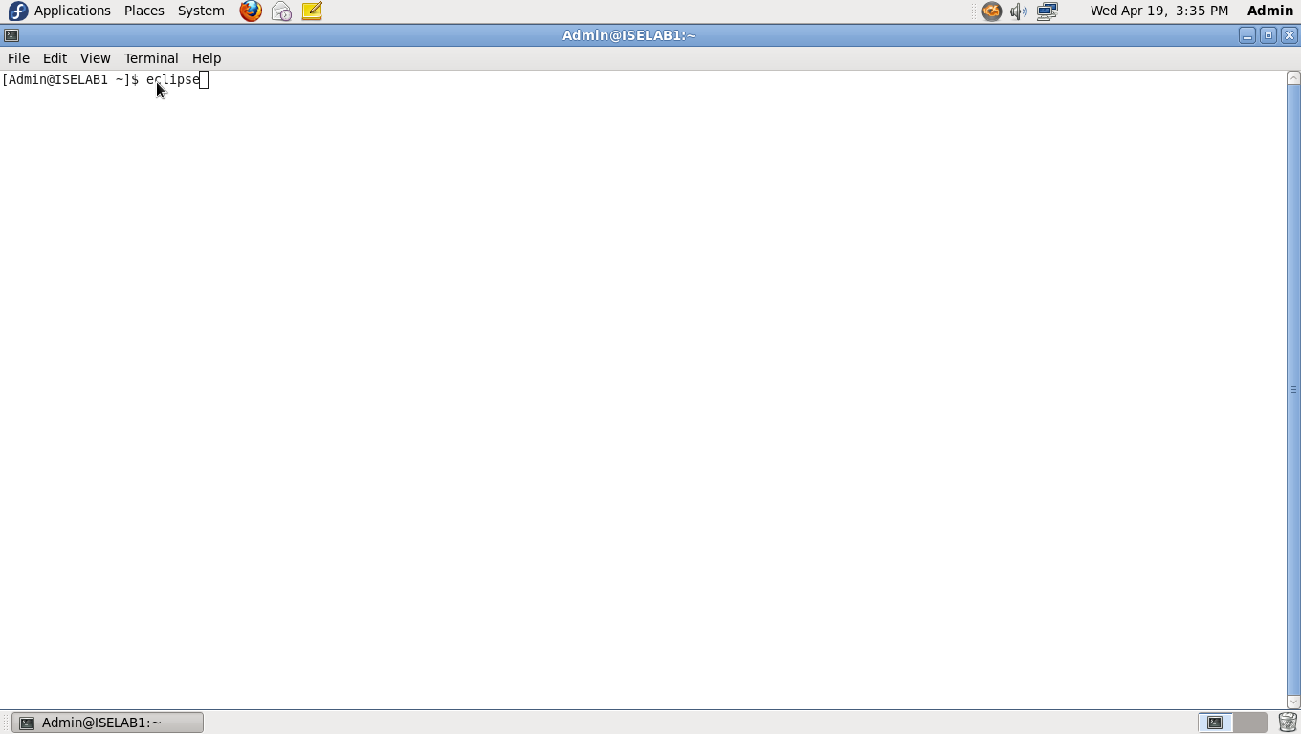

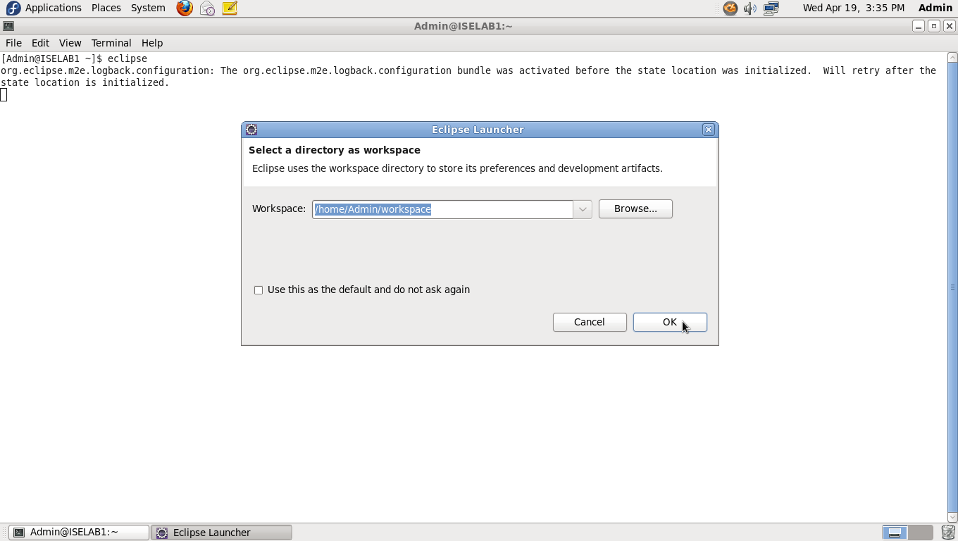

This step will show you how to create a Java application project in Eclipse.

1. Choose File → New → Project -> Java Project from the Eclipse menu bar, as in the following example:

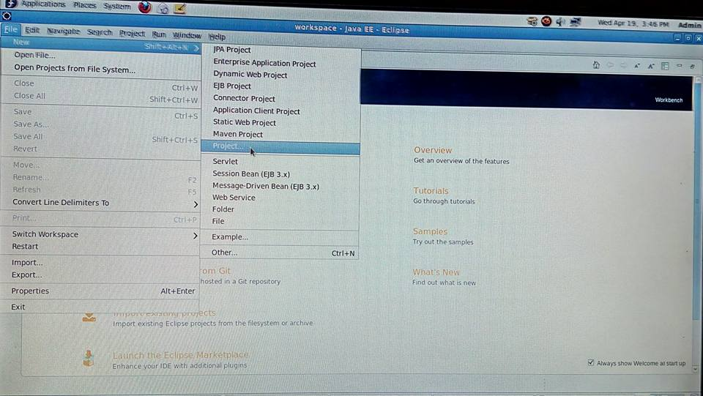

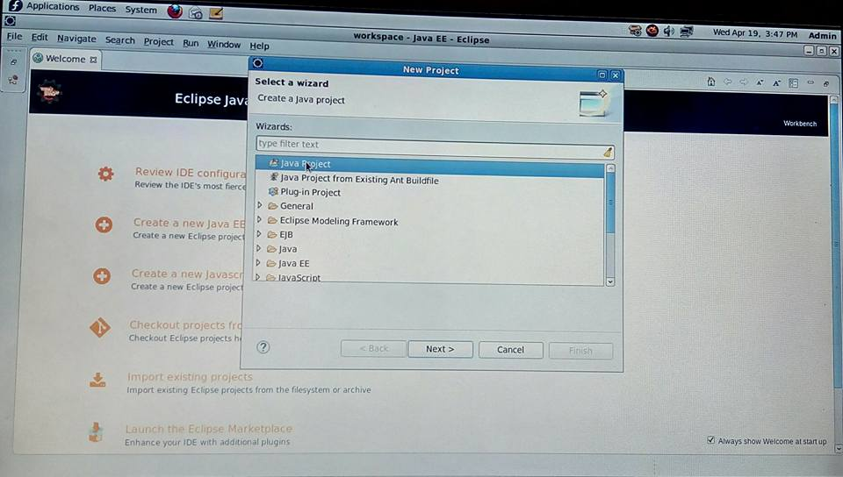

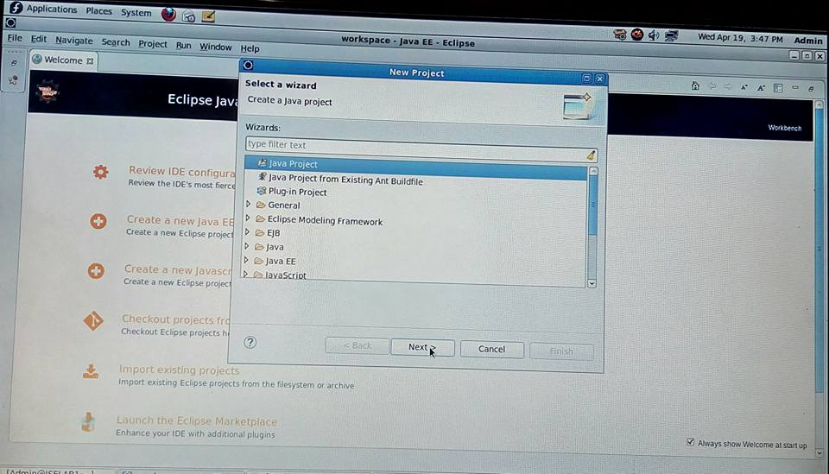

1. The following window will be displayed. Enter the Project name and make sure the "Use Project folder as root for sources and class files" option is selected in the "Project layout".

Select

JRE

* Use a project specific JRE :

Project

* Create separate folders for sources and class files

1. section as shown in the image below:

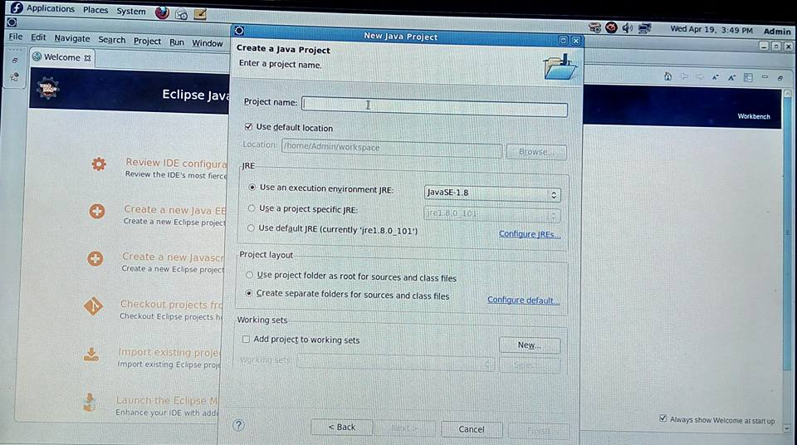

1. If you click the "Configure default..." link in the "Project Layout" area, you can make these settings your default settings for new projects.  Select "Project" for the "Source and output folder" option and click "OK" button.  We recommend that students configure Eclipse in this way.

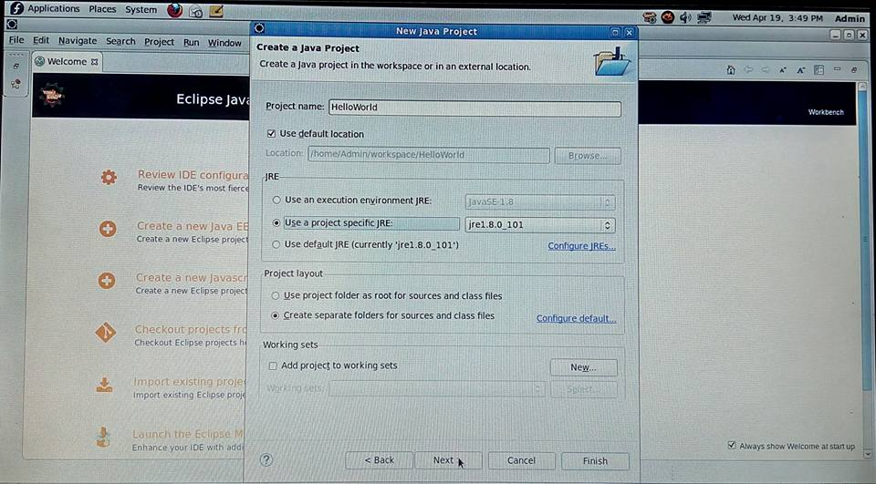

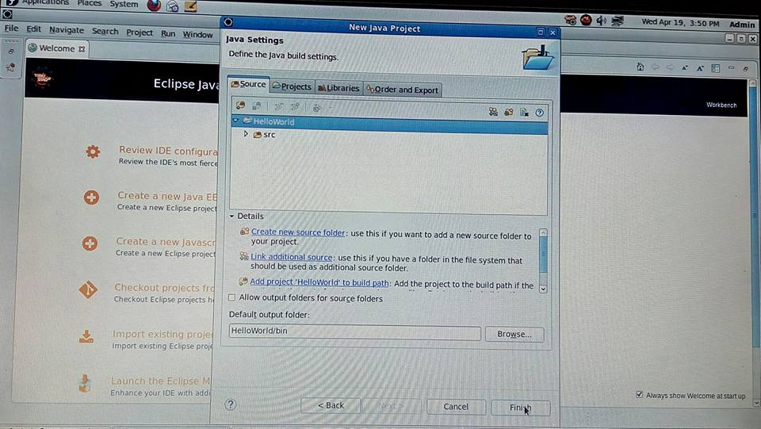

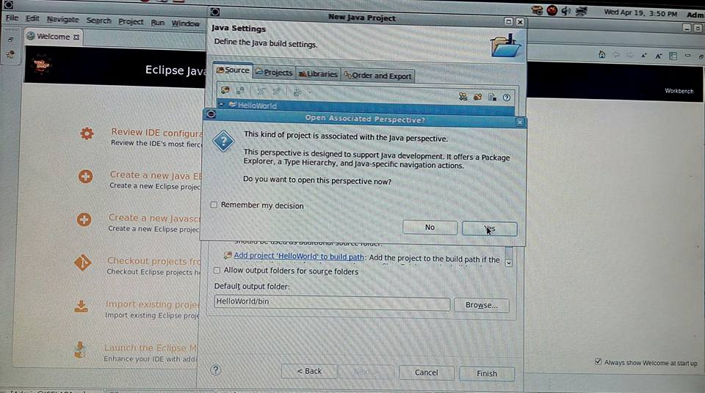

1. After returning to the New Project Wizard dialog box, click Finish to actually create the project you just described. The following screen will be displayed, denoting a workspace with one project to choose from the Package Explorer:

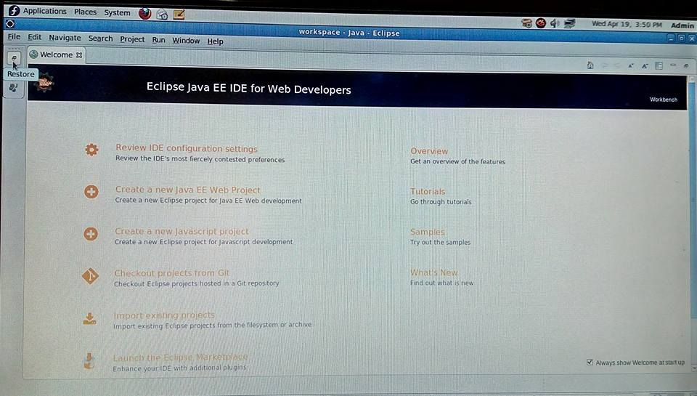

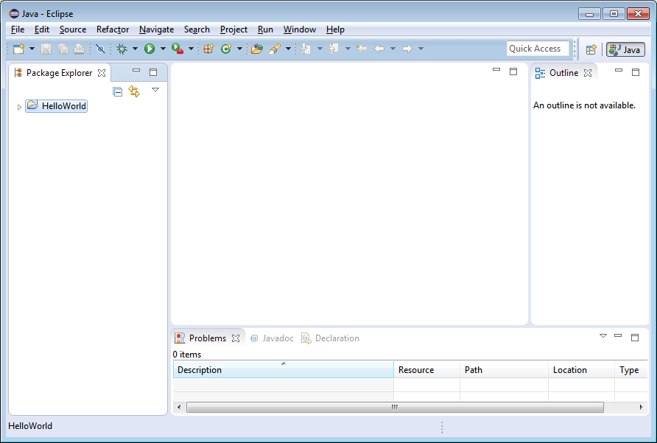

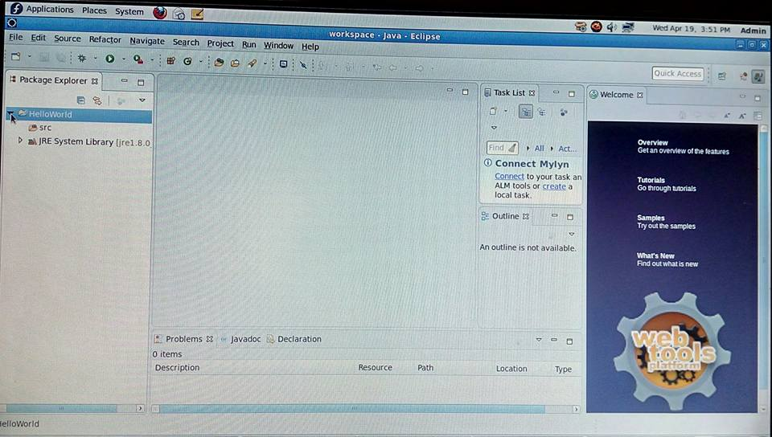

1. Next comes putting some substance (code) into the project to make a working program!

This step will show you how to edit a source file in Eclipse.

1. Launch the Eclipse IDE if it is not currently running. Return to [Step 1](http://pages.cs.wisc.edu/~cs302/labs/EclipseTutorial/startTutorial.html) you need help completing this step.
2. To create a source file where we will write our program. Select on the "HelloWorld" project in the Package Explorer, Right-click on the **src** tabbed pane on the left side of the screen and navigate to New → Class, as in the following example:

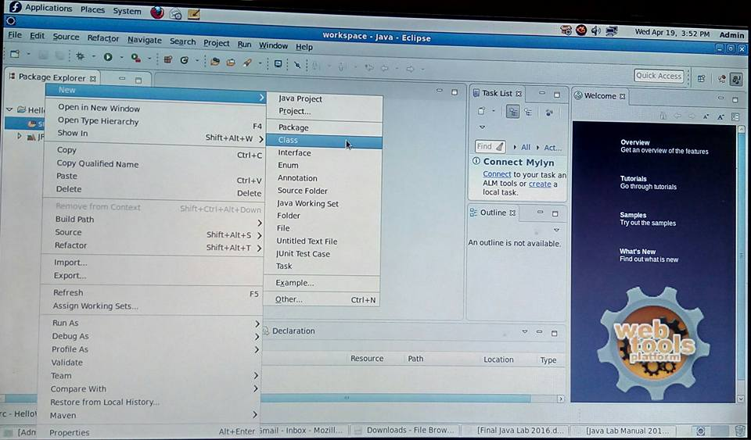

1. Another window will be displayed. Then click in the text box labeled "Name:" and type in HW, as in the following example:

Select

* Public static void main(String[] args)

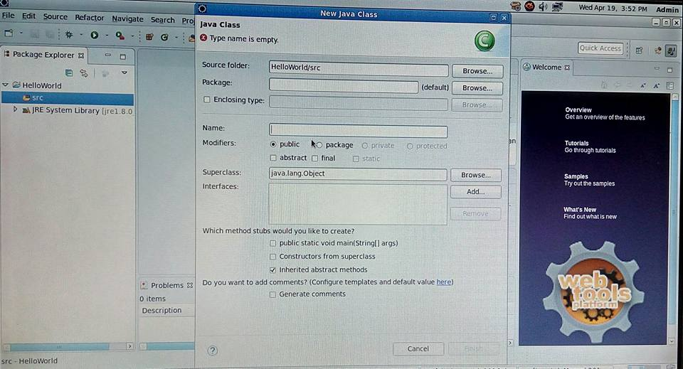

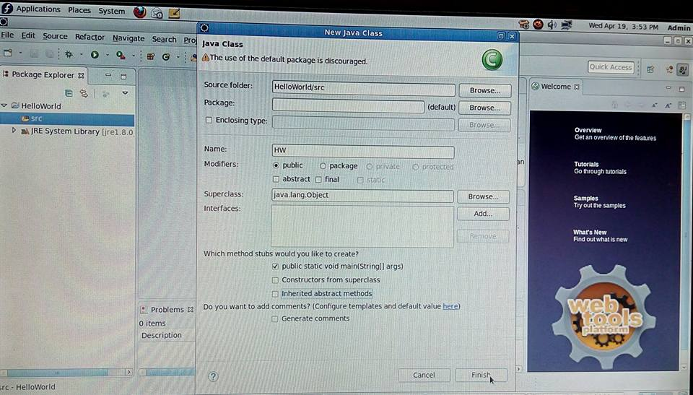

Click Finish. This step will create a new file named HW.java and add it to the project for you. It will also open a tabbed window where you can edit the HW.java source file.

1. Now that we've completed the setup we can write the program. Enter the following text into the HW.java window.

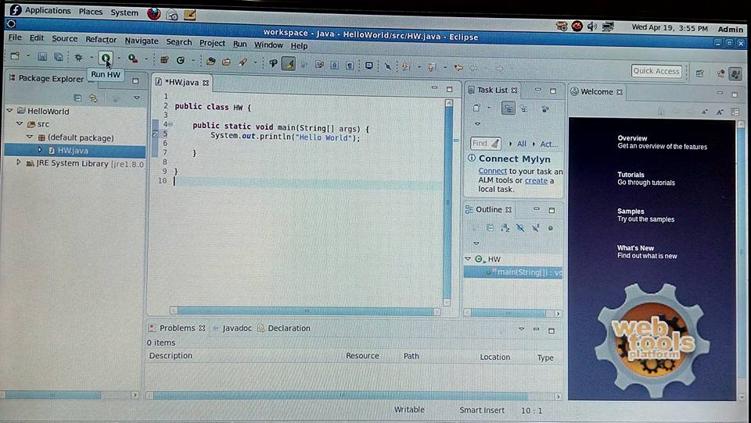

This step will show you how to compile and run your Java program in Eclipse.

1. Go to the left Package Explorer pane. The **HelloWorld** folder should be opened, but if it is not, double-click on folder to open it. Then, double click on the "(default package)" to access the HW.java file. Right-click on the file and select Run As → Java Application, as in the following image:

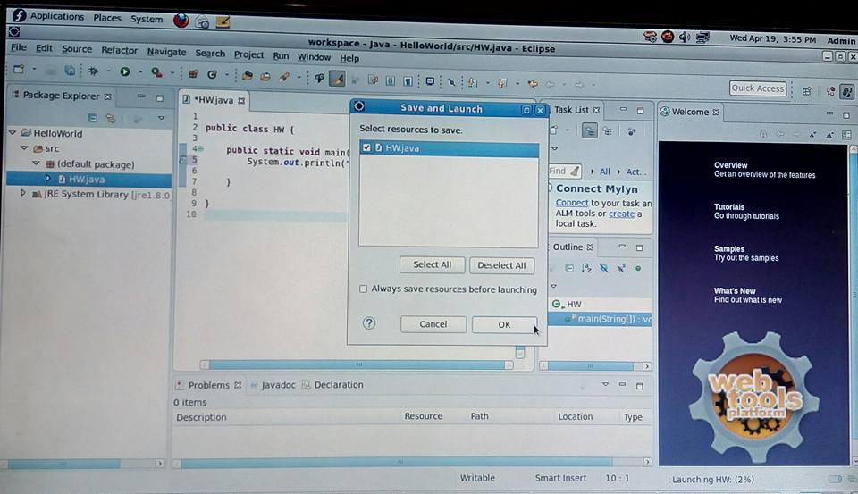

Once you run the **HelloWorld** program, you should notice output in the Console pane:

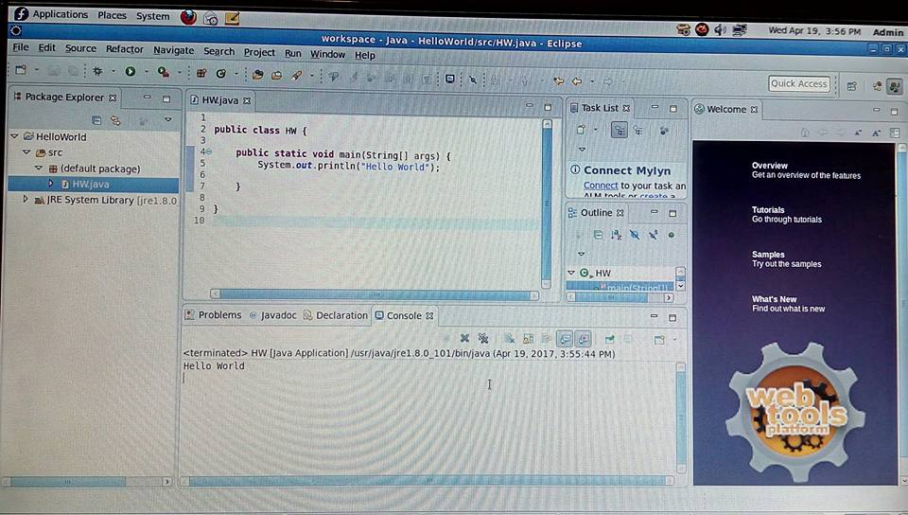

1. Note that you may have to click on the tab labeled "Console" to see this output.

Now we will do one more project, which demonstrates the adding of a jar file.

**Part A**

1. **Design an algorithm to accept a value for ‘n’ and calculate the total number of all possible squares in a square matrix.**

SquareMatrix.java

**import** java.util.Scanner;

**public** **class** SqareMatrix

{

**public** **static** **void** main(String[] args)

{

Scanner in=**new** Scanner(System.***in***);

**while**(**true**)

{

System.***out***.print("Enter the value of n for n-Square Matrix : ");

**int** n=in.nextInt();

**if**(n<=0)

System.***out***.println("invalid input");

**else**

{

**int** sum=0;

**while**(n!=0)

{

sum=sum+n*n;

n--;

}

System.***out***.println("The number square matrices are : " +sum);

}

}

}

}

Console Output

Enter the value of n for n-Square Matrix : 4

The number square matrices are : 30

Enter the value of n for n-Square Matrix : 5

The number square matrices are : 55

Enter the value of n for n-Square Matrix : 2

The number square matrices are : 5

Enter the value of n for n-Square Matrix : 0

invalid input

Enter the value of n for n-Square Matrix :

1. **Design an algorithm for simple calculator which takes input from the user and also details of what operation must be performed. The user can input only 2 operands**

TwoOperands.java

**import** java.util.Scanner;

**public** **class** TwoOperands

{

**public** **static** **void** main(String[] args)

{

Scanner in=**new** Scanner(System.***in***);

**int** ch=0;

**do**

{

System.***out***.println("Please enter value for first operand : ");

**double** a=in.nextDouble();

System.***out***.println("Please enter value for second operand : ");

**double** b=in.nextDouble();

System.***out***.println("Select the operation to be performed");

System.***out***.println("1. Addition");

System.***out***.println("2. Subtraction");

System.***out***.println("3. Multiplication");

System.***out***.println("4. Division");

System.***out***.println("5. Exit");

System.***out***.print("Enter the option : ");

ch=in.nextInt();

**switch**(ch)

{

**case** 1:

System.***out***.println("The addition of two numbers is : " +(a+b));

**break**;

**case** 2:

System.***out***.println("The subtraction of two numbers is : " +(a-b));

**break**;

**case** 3:

System.***out***.println("The multiplication of two numbers is : " +(a*b));

**break**;

**case** 4:

System.***out***.println("The division of two numbers is : " +(a/b));

**break**;

**case** 5:

System.*exit*(0);

**default**:

System.***out***.println("Please enter valid option");

**break**;

}

}

**while**(ch!=5);

}

}

Console Output

Please enter value for first operand :

2

Please enter value for second operand :

3

Select the operation to be performed

1. Addition

2. Subtraction

3. Multiplication

4. Division

5. Exit

Enter the option : 1

The addition of two numbers is : 5.0

Please enter value for first operand :

2

Please enter value for second operand :

3

Select the operation to be performed

1. Addition

2. Subtraction

3. Multiplication

4. Division

5. Exit

Enter the option : 2

The subtraction of two numbers is : -1.0

Please enter value for first operand :

2

Please enter value for second operand :

3

Select the operation to be performed

1. Addition

2. Subtraction

3. Multiplication

4. Division

5. Exit

Enter the option : 3

The multiplication of two numbers is : 6.0

Please enter value for first operand :

2

Please enter value for second operand :

3

Select the operation to be performed

1. Addition

2. Subtraction

3. Multiplication

4. Division

5. Exit

Enter the option : 4

The division of two numbers is : 0.6666666666666666

Please enter value for first operand :

2

Please enter value for second operand :

3

Select the operation to be performed

1. Addition

2. Subtraction

3. Multiplication

4. Division

5. Exit

Enter the option : 6

Please enter valid option

Please enter value for first operand :

2

Please enter value for second operand :

3

Select the operation to be performed

1. Addition

2. Subtraction

3. Multiplication

4. Division

5. Exit

Enter the option : 5

1. **Design an algorithm to print a pyramid based on level entered by the user**

Pyramid.java

**import** java.util.Scanner;

**public** **class** Pyramid

{

**public** **static** **void** main(String[] args)

{

Scanner in=**new** Scanner(System.***in***);

System.***out***.print("Enter the number of levels for the number pyramid : ");

**int** levels=in.nextInt();

**for**(**int** row=1;row<levels+1;row++)

{

**for**(**int** space=row;space<levels;space++)

{

System.***out***.print(" ");

}

**for**(**int** col=row;col<=2*row-1;col++)

{

System.***out***.print(col+" ");

}

**for**(**int** k=2*row-2;k>=row;k--)

{

System.***out***.print(k+" ");

}

System.***out***.println();

}

}

}

Console Output

Enter the number of levels for the number pyramid : 6

1

2 3 2

3 4 5 4 3

4 5 6 7 6 5 4

5 6 7 8 9 8 7 6 5

6 7 8 9 10 11 10 9 8 7 6

1. **Design an algorithm to accept 5 strings from the user and print them in lexicographical** order.

Lexicographical.java

**import** java.util.Arrays;

**import** java.util.Scanner;

**public** **class** Lexicographical

{

**public** **static** **void** main(String[] args)

{

Scanner in=**new** Scanner(System.***in***);

String[] ls=**new** String[5];

System.***out***.println("Enter five strings : ");

System.***out***.print("First : ");

ls[0]=in.next();

System.***out***.print("Second : ");

ls[1]=in.next();

System.***out***.print("Third : ");

ls[2]=in.next();

System.***out***.print("Fourth : ");

ls[3]=in.next();

System.***out***.print("Fifth : ");

ls[4]=in.next();

Arrays.*sort*(ls);

**for**(**int** i=0;i<5;i++)

{

System.***out***.println(ls[i]);

}

}

}

Console Output

Enter five strings :

First : banana

Second : anana

Third : nana

Fourth : na

Fifth : a

a

anana

banana

na

nana

1. **Design and implement a java program to find digit sum two digit number until the digit sum is less than 10.**

DigitSum.java

**import** java.util.Scanner;

**public** **class** DigitSum

{

**public** **static** **void** main(String[] args)

{

Scanner in=**new** Scanner(System.***in***);

System.***out***.print("Enter the number to find digitsum : ");

**int** num=in.nextInt();

**int** sum=num;

**int** fin=0;

**int** fin1=0;

String temp=Integer.*toString*(num);

**int** len=temp.length();

**for**(**int** i=0;i<len;i++)

{

System.***out***.println("1 : " +sum%10);

fin=fin+sum%10;

**if**(Integer.*toString*(fin).length()!=1)

{

**for**(**int** j=0;j<=Integer.*toString*(fin).length();j++)

{

System.***out***.println("2 : " +fin%10);

fin1=fin1+fin%10;

fin=fin/10;

}

fin=fin1;

}

sum=sum/10;

}

System.***out***.println("3 : " +fin);

}

}

Console Output

Enter the number to find digitsum : 44

1 : 4

1 : 4

3 : 8

Enter the number to find digitsum : 99

1 : 9

1 : 9

2 : 8

2 : 1

3 : 9

1. **Design an algorithm which accepts a number (which is non-zero and positive) from the user and then checks if it is a happy number or not.**

HappyorUnhappyNumber.java

**import** java.util.Scanner;

**import** java.util.concurrent.Callable;

**public** **class** HappyorUnhappyNumber

{

**int** fin1=0;

**int** sum=0;

**public** **static** **void** main(String[] args)

{

Scanner in=**new** Scanner(System.***in***);

System.***out***.print("Enter the number to be tested as happy or unhappy : ");

**int** num=(**int**)Math.*pow*(in.nextInt(), 2);

System.***out***.println(num);

HappyorUnhappyNumber p=**new** HappyorUnhappyNumber();

**while**(num>9)

{

System.***out***.println(p.callMe(num));

num=p.callMe(num);

}

**if**(num==1)

System.***out***.println("Its a happy number : )");

**else**

System.***out***.println("Its unhappy :(");

}

**int** callMe(**int** sum)

{

**int** fin=0;

String temp=Integer.*toString*(sum);

**int** len=temp.length();

**for**(**int** i=0;i<len;i++)

{

System.***out***.println("1 : " +(**int**)Math.*pow*(sum%10,2));

fin=fin+(**int**)Math.*pow*(sum%10,2);

sum=sum/10;

}

sum=fin;

**return** sum;

}

}

Console Output

Enter the number to be tested as happy or unhappy : 7

49

1 : 81

1 : 16

97

1 : 81

1 : 16

1 : 49

1 : 81

130

1 : 49

1 : 81

1 : 0

1 : 9

1 : 1

10

1 : 0

1 : 9

1 : 1

1 : 0

1 : 1

1

1 : 0

1 : 1

Its a happy number : )

Enter the number to be tested as happy or unhappy : 4

16

1 : 36

1 : 1

37

1 : 36

1 : 1

1 : 49

1 : 9

58

1 : 49

1 : 9

1 : 64

1 : 25

89

1 : 64

1 : 25

1 : 81

1 : 64

145

1 : 81

1 : 64

1 : 25

1 : 16

1 : 1

42

1 : 25

1 : 16

1 : 1

1 : 4

1 : 16

20

1 : 4

1 : 16

1 : 0

1 : 4

4

1 : 0

1 : 4

Its unhappy :(

1. **Design an algorithm which accepts a Room Number, Mobile Number and Name of the Customer and generate a 6 Character Unique Password.**

UniquePassword.java

**import** java.util.Scanner;

**public** **class** UniquePassword

{

**public** **static** **void** main(String[] args)

{

Scanner s=**new** Scanner(System.***in***);

String name;

String pw=**new** String();

**long** ph;**int** rno,rem,sum=0;

System.***out***.println("Enter the name : ");

name=s.next();

System.***out***.println("Enter the room no : ");

rno=s.nextInt();

**int** rno1=rno;

System.***out***.println("Enter the phone number : ");

ph=s.nextLong();

**char** []sym={')','!','@','#','$','%','^','&','*','('};

**do**

{

**while**(rno!=0)

{

rem=rno%10;

sum=sum+rem;

rno=rno/10;

}

**if**(sum>=10)

{

rno=sum;

sum=0;

}

}**while**(rno!=0);

**int** c=rno1/100;

**int** len=name.length();

**int** pos=0;

**for**(**int** i=0;i<len;i++)

{

**if**(c==i)

{

pos=i;

System.***out***.println("Password is : ");

}

}

pw=""+name.charAt(0)+(ph%10)+sum+sym[c]+name.charAt(len-1);

System.***out***.println(pw);

}

}

Console Output

Enter the name :

abc

Enter the room no :

123

Enter the phone number :

8574236415

Password is :

a56!c

**Part B**

1. **Develop a small java application, which accepts employee id from the command prompt and displays the details using arrays.**

Emp No Emp Name Department Designation and Salary

Your may assume that the array is initialized with the following details

|  |  |  |  |  |  |  |  |
| --- | --- | --- | --- | --- | --- | --- | --- |
| **Emp No.** | **Emp Name** | **Join Date** | **Desig Code** | **Dept** | **Basic** | **HRA** | **IT** |
| 1001 | Abc | 01/04/2009 | E | R&D | 20000 | 8000 | 3000 |
| 1002 | Opqr | 23/08/2012 | C | PM | 30000 | 12000 | 9000 |
| 1003 | Ghi | 12/11/2008 | K | Acct | 10000 | 8000 | 1000 |
| 1004 | Wxyz | 29/01/2013 | R | Front Desk | 12000 | 6000 | 2000 |
| 1005 | Jklmn | 16/07/2005 | M | Engg | 50000 | 20000 | 20000 |
| 1006 | Stuv | 01/01/2000 | E | Manufacturing | 23000 | 9000 | 4400 |
| 1007 | Def | 12/06/2006 | C | PM | 29000 | 12000 | 10000 |

Salary is calculated as Basic+HRA+DA-IT. (DA details are given in the Designation table)

Designation details:

|  |  |  |
| --- | --- | --- |
| **Designation Code** | **Designation** | **DA** |
| e | Engineer | 20000 |
| c | Consultant | 32000 |
| k | Clerk | 12000 |
| r | Receptionist | 15000 |
| m | Manager | 40000 |

Use Switch-Case to print Designation in the output and to find the value of DA for a particular employee

Employee.java

import java.util.Date;

import java.util.Stack;

public class Employee

{

public static void main(String[] args)

{

System.out.println("Enter Valid Employee ID : \n");

int[] EmpId={1001,1002,1003,1004,1005,1006,1007};

String[] EmpName={"Abc","Opqr","Ghi","Wxyz","Jklmn","Stuv","Def"};

String[] JoinDate={"01/04/2009","23/08/2012","12/11/2008","29/01/2013","16/07/2005","01/01/2000","12/06/2006"};

char[] DesigCode={'e','c','k','r','m','e','c'};

String[] Department={"R&D","PM","Acct","Front Desk","Engg","Manufacturing","PM"};

double[] Basic={20000,30000,10000,12000,50000,23000,29000};

double[] HRA={8000,12000,8000,6000,20000,9000,12000};

double[] IT={3000,9000,1000,2000,20000,4400,10000};

char[] DesignationCode={'e','c','k','r','m'};

String[] Designation={"Engineer","Consultant","Clerk","Receptionist","Manager"};

double[] DA={20000,32000,12000,15000,40000};

int flag=0;

int id=Integer.parseInt(args[0]);

for(int i=0;i<EmpId.length;i++)

{

if(EmpId[i]==id)

{

flag=1;

System.out.println("Emp Id. Emp Name Department Designation DA");

System.out.print(EmpId[i]+" "+EmpName[i]+" "+Department[i]);

for(int j=0;j<DesignationCode.length;j++)

{

if(DesigCode[i]==DesignationCode[j])

{ System.out.print(" "+Designation[j]+" ");

double sum=Basic[i]+HRA[i]+DA[j]-IT[i];

System.out.print(sum);

}

}

}

}

if(flag==0)

System.out.println("There is no employee with EmpId : " +id);

}

}

Output

1. Run -> Run Configurations

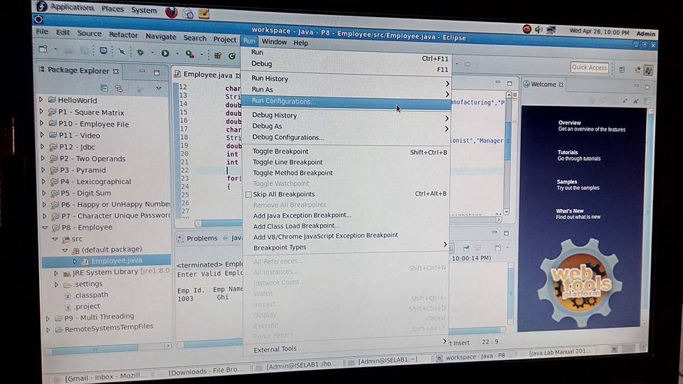

2. Select Arguments

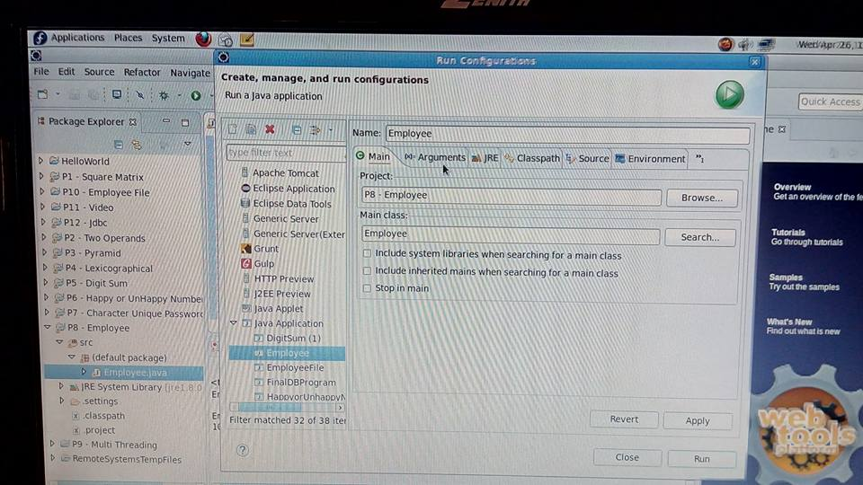

3. Enter Valid Employee ID :

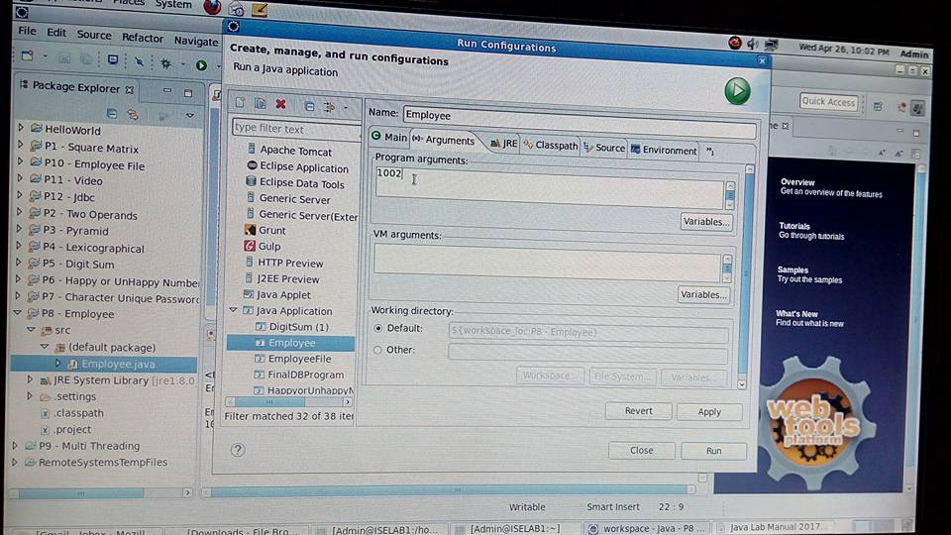

4. Apply

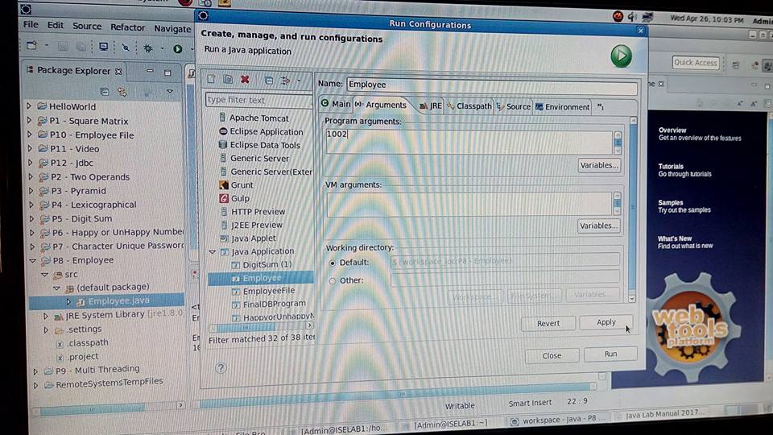

5. Run

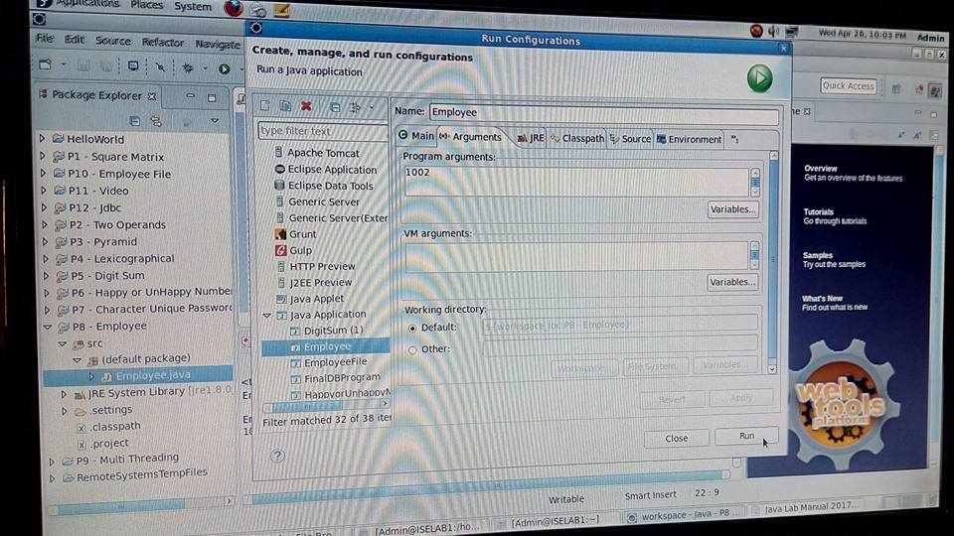

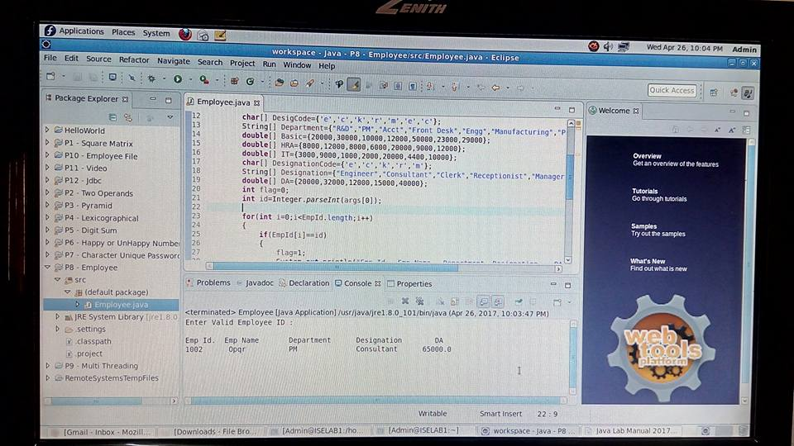

Console Output

Enter Valid Employee ID :

Emp Id. Emp Name Department Designation DA

1002 Opqr PM Consultant 65000.0

1. **Develop a small java application, which uses concepts of Multithreading**

MultiThreading.java

**import java.util.Date;**

**public** **class** MultiThreading **implements** Runnable

{

Thread t;

**static** **int**[] *a*=**new** **int**[51];

**static** **int** *sum*=0;

MultiThreading(String name)

{

t=**new** Thread(**this**, name);

System.***out***.println("childthread:"+t);

t.start();

}

**public** **void** run()

{

System.***out***.println(Thread.*currentThread*().getName());

**if**(Thread.*currentThread*().getName().compareTo("one")==0)

{

**for**(**int** i=0;i<10;i++)

{

*sum*=*sum*+*a*[i];

**try**

{

Thread.*sleep*(1000);

}

**catch** (InterruptedException e)

{

e.printStackTrace();

}

System.***out***.println("Sum of 1-10 : " +*sum*);

}

//total=total+sum;

}

**else** **if**(Thread.*currentThread*().getName().compareTo("two")==0)

{

**for**(**int** j=10;j<20;j++)

{

*sum*=*sum*+*a*[j];

**try**

{

Thread.*sleep*(1000);

}

**catch** (InterruptedException e)

{

// **TODO** Auto-generated catch block

e.printStackTrace();

}

System.***out***.println("Sum of 10-20 : " +*sum*);

}

//total=total+sum;

}

**else** **if**(Thread.*currentThread*().getName().compareTo("three")==0)

{

**for**(**int** k=20;k<30;k++)

{

*sum*=*sum*+*a*[k];

**try**

{

Thread.*sleep*(1000);

}

**catch** (InterruptedException e)

{

e.printStackTrace();

}

System.***out***.println("Sum of 20-30 : " +*sum*);

}

//total=total+sum;

}

**else** **if**(Thread.*currentThread*().getName().compareTo("four")==0)

{

**for**(**int** l=30;l<40;l++)

{

*sum*=*sum*+*a*[l];

**try**{

Thread.*sleep*(1000);

}**catch** (InterruptedException e) {

// **TODO** Auto-generated catch block

e.printStackTrace();

}

System.***out***.println("Sum of 30-40 : " +*sum*);

}

//total=total+sum;

}

**else** **if**(Thread.*currentThread*().getName().compareTo("five")==0)

{

**for**(**int** m=40;m<50;m++)

{

*sum*=*sum*+*a*[m];

**try**

{

Thread.*sleep*(1000);

}

**catch** (InterruptedException e)

{

e.printStackTrace();

}

System.***out***.println("Sum of 40-50 : " +*sum*);

//total=total+sum;

}

//System.out.println("Total sum is : " +total);

}

}

**public** **static** **void** main(String[] args)

{

**for**(**int** x=0;x<51;x++)

{

*a*[x]=x+1;

}

System.***out***.println(Thread.*currentThread*().getName());

MultiThreading ob1=**new** MultiThreading("one");

MultiThreading ob2=**new** MultiThreading("two");

MultiThreading ob3=**new** MultiThreading("three");

MultiThreading ob4=**new** MultiThreading("four");

MultiThreading ob5=**new** MultiThreading("five");

Date start=**new** Date();

System.***out***.println("First Thread is Alive? : " +ob1.t.isAlive());

System.***out***.println("Second Thread is Alive? : " +ob2.t.isAlive());

System.***out***.println("Third Thread is Alive? : " +ob3.t.isAlive());

System.***out***.println("Fourth Thread is Alive? : " +ob4.t.isAlive());

System.***out***.println("Fivth Thread is Alive? : " +ob5.t.isAlive());

**try**

{

System.***out***.println("waiting for Threads to complete");

ob1.t.join();

ob2.t.join();

ob3.t.join();

ob4.t.join();

ob5.t.join();

}

**catch** (InterruptedException e)

{

// **TODO** Auto-generated catch block

e.printStackTrace();

}

System.***out***.println("Total sum is : " +*sum*);

System.***out***.println("First Thread is Alive? :"+ob1.t.isAlive());

System.***out***.println("Second Thread is Alive? :"+ob2.t.isAlive());

System.***out***.println("Third Thread is Alive? :"+ob3.t.isAlive());

System.***out***.println("Fourth Thread is Alive? :"+ob4.t.isAlive());

System.***out***.println("Fivth Thread is Alive? :"+ob5.t.isAlive());

System.***out***.println("Main thread is interupted ");

Date end=**new** Date();

**long** difference=end.getTime()-start.getTime();

System.***out***.println("Whole process took "+difference/1000 +" " +"seconds");

System.***out***.println("Mian thread is exiting");

}

}

Console Output

**main**

childthread:Thread[one,5,main]

childthread:Thread[two,5,main]

one

childthread:Thread[three,5,main]

two

childthread:Thread[four,5,main]

three

childthread:Thread[five,5,main]

four

First Thread is Alive? : true

Second Thread is Alive? : true

Third Thread is Alive? : true

Fourth Thread is Alive? : true

Fivth Thread is Alive? : true

waiting for Threads to complete

five

Sum of 1-10 : 105

Sum of 10-20 : 107

Sum of 20-30 : 119

Sum of 30-40 : 141

Sum of 40-50 : 173

Sum of 1-10 : 215

Sum of 10-20 : 218

Sum of 20-30 : 231

Sum of 30-40 : 254

Sum of 40-50 : 287

Sum of 1-10 : 330

Sum of 10-20 : 334

Sum of 20-30 : 348

Sum of 30-40 : 372

Sum of 40-50 : 406

Sum of 1-10 : 450

Sum of 10-20 : 455

Sum of 20-30 : 470

Sum of 30-40 : 495

Sum of 40-50 : 530

Sum of 1-10 : 575

Sum of 10-20 : 581

Sum of 20-30 : 597

Sum of 30-40 : 623

Sum of 40-50 : 659

Sum of 1-10 : 705

Sum of 10-20 : 712

Sum of 20-30 : 729

Sum of 30-40 : 756

Sum of 40-50 : 793

Sum of 1-10 : 840

Sum of 10-20 : 848

Sum of 20-30 : 866

Sum of 30-40 : 894

Sum of 40-50 : 932

Sum of 1-10 : 980

Sum of 10-20 : 989

Sum of 20-30 : 1008

Sum of 30-40 : 1037

Sum of 40-50 : 1076

Sum of 1-10 : 1125

Sum of 10-20 : 1135

Sum of 20-30 : 1155

Sum of 30-40 : 1185

Sum of 40-50 : 1225

Sum of 1-10 : 1275

Sum of 10-20 : 1275

Sum of 20-30 : 1275

Sum of 30-40 : 1275

Sum of 40-50 : 1275

Total sum is : 1275

First Thread is Alive? :false

Second Thread is Alive? :false

Third Thread is Alive? :false

Fourth Thread is Alive? :false

Fivth Thread is Alive? :false

Main thread is interupted

Whole process took 10 seconds

Mian thread is exiting

1. **Design and Implement GUI for managing Employee Details using concepts of Files.**

EmployeeFile.java

import java.awt.Color;

import java.awt.Dimension;

import java.awt.GridLayout;

import java.awt.event.ActionEvent;

import java.awt.event.ActionListener;

import java.io.File;

import java.io.FileWriter;

import java.io.IOException;

import javax.swing.*;

public class EmployeeFile

{

private static Color black;

public static void main(String[] args)

{

JFrame frameobj = new JFrame(); //creating frame

frameobj.setSize(500, 500); //declaring frame size

GridLayout g1=new GridLayout(5,2); // layout of the frame

frameobj.setLayout(g1); //layout is set to the frame created

JPanel p1=new JPanel(); //creating panels

JPanel p2=new JPanel();

JPanel p3=new JPanel();

JPanel p4=new JPanel();

JPanel p5=new JPanel();

JPanel p6=new JPanel();

JPanel p7=new JPanel();

JPanel p8=new JPanel();

JPanel p9=new JPanel();

JPanel p10=new JPanel();

JLabel l1=new JLabel("NAME"); //creating labels

JLabel l2=new JLabel("ID");

JLabel l3=new JLabel("DOJ");

JLabel l4=new JLabel("DOB");

JTextField f1=new JTextField(); //create obj for txtfield

JTextField f2=new JTextField();

JTextField f3=new JTextField();

JTextField f4=new JTextField();

f1.setPreferredSize(new Dimension(200,30)); //size of txtfield

f2.setPreferredSize(new Dimension(200,30));

f3.setPreferredSize(new Dimension(200,30));

f4.setPreferredSize(new Dimension(200,30));

JButton b1=new JButton("SUBMIT");

JButton b2=new JButton("RESET");

b1.addActionListener(new ActionListener()

{

@Override

public void actionPerformed(ActionEvent e)

{

File fileobj=new File("/home/Admin/workspace/P10 - Employee File/File.txt");

try

{

FileWriter fw=new FileWriter(fileobj.getAbsoluteFile(),true);

System.out.println("\n NAME : " +f1.getText() +"\n" +"ID : " +f2.getText() +"\n" +"DOJ : " +f3.getText() +"\n" +"DOB : "+f4.getText() +"\n");

fw.write("\n NAME : " +f1.getText() +"\n" +"ID : " +f2.getText() +"\n" +"DOJ : " +f3.getText() +"\n" +"DOB : "+f4.getText() +"\n");

fw.close();

}

catch (IOException e1)

{

e1.printStackTrace();

}

}

});

b2.addActionListener(new ActionListener()

{

@Override

public void actionPerformed(ActionEvent e)

{

f1.setText(" ");

f2.setText(null);

f3.setText(null);

f4.setText(null);

}

});

p1.add(l1); //add labels to panels where labels=name,id,doj,dob

p3.add(l2);

p5.add(l3);

p7.add(l4);

p2.add(f1); //add textfield to panels where txtfield is user defined

p4.add(f2);

p6.add(f3);

p8.add(f4);

p9.add(b1); //add buttons to panel

p10.add(b2);

//l1.setBorder(BorderFactory.createLineBorder(Color.black));

l1.setBorder(BorderFactory.createLineBorder(black,10));

l2.setBorder(BorderFactory.createLineBorder(black,10));

l3.setBorder(BorderFactory.createLineBorder(black,10));

l4.setBorder(BorderFactory.createLineBorder(black,10));

frameobj.add(p1); //add panels to frames

frameobj.add(p2);

frameobj.add(p3);

frameobj.add(p4);

frameobj.add(p5);

frameobj.add(p6);

frameobj.add(p7);

frameobj.add(p8);

frameobj.add(p9);

frameobj.add(p10);

frameobj.setVisible(true);

}

}

Output

1. Run

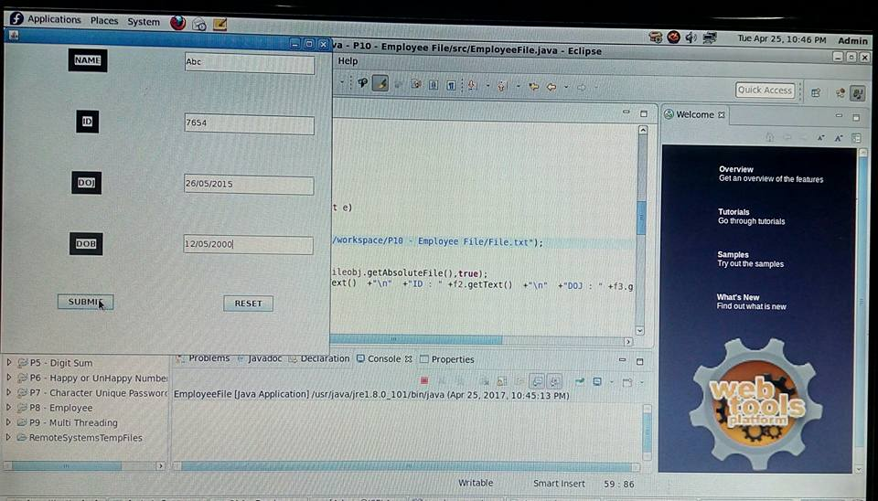

2. Go to folder & open file

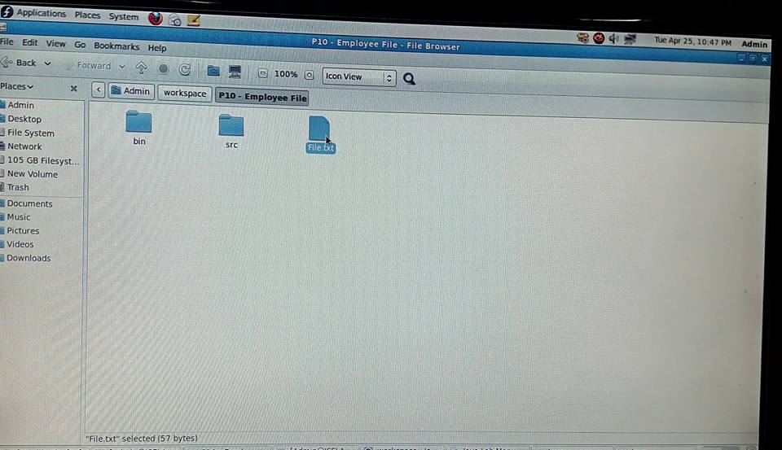

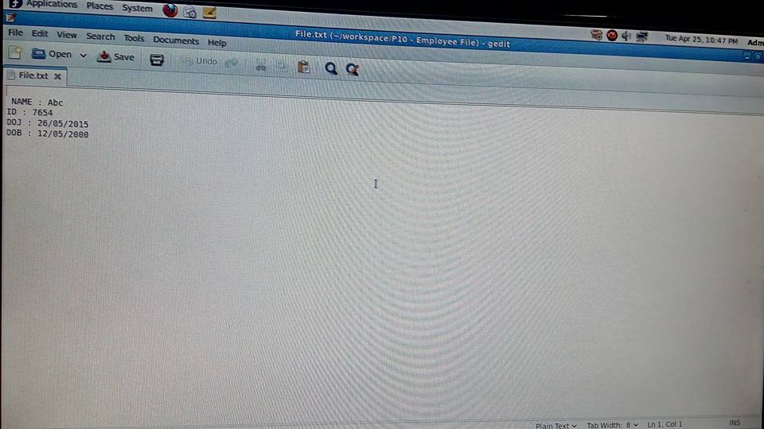

Console Output

NAME : Abc

ID : 7654

DOJ : 26/05/2015

DOB : 12/05/2000

Note : Same output should be written into the file

1. **Design and implement a simple inventory central system for a small video rental store using constructors and Object List.**

Bean Class File : Video.java

**public** **class** Video

{

String mName;

**boolean** status;

**double** rating;

**public** Video(String mName, **boolean** status, **double** rating)

{

**super**();

**this**.mName = mName;

**this**.status = status;

**this**.rating = rating;

}

**public** String getmName()

{

**return** mName;

}

**public** **void** setmName(String mName)

{

**this**.mName = mName;

}

**public** **boolean** isStatus()

{

**return** status;

}

**public** **void** setStatus(**boolean** status)

{

**this**.status = status;

}

**public** **double** getRating()

{

**return** rating;

}

**public** **double** setRating(**double** rating)

{

**return** **this**.rating = rating;

}

}

Methods Class File : VideoMethods.java

**import** java.util.List;

**import** java.util.Scanner;

**import** java.util.ArrayList;

**public** **class** VideoMethods

{

List<Video> MovieList = **new** ArrayList<Video>();

**public** **void** AddMovies()

{

Scanner in=**new** Scanner(System.***in***);

System.***out***.print("Enter the name of the movie:");

String mName=in.nextLine();

System.***out***.print("Enter the status of the movie(True/False):");

**boolean** status=in.nextBoolean();

System.***out***.print("Enter the ratings for the movie(0-5):");

**double** rating=in.nextDouble();

Video v=**new** Video(mName, status, rating);

MovieList.add(v);

System.***out***.println("Library Initialized");

}

**public** **void** DisplayAll()

{

**if**(MovieList.isEmpty())

{

System.***out***.println("No movies in the library");

}

**for**(Video m : MovieList)

{

System.***out***.println("Movie : " +m.getmName()+" "+"Status : "+m.isStatus()+" "+"Rating "+m.getRating());

}

}

**boolean** RentOut(String name)

{

**for**(Video m :MovieList)

{

**if**(m.getmName().equalsIgnoreCase(name))

{

**if**(m.isStatus())

{

m.setStatus(**false**);

**return** **true**;

}

}

**return** **false**;

}

**return** **false**;

}

**public** **void** CollectIn(String name,**double** rat)

{

**boolean** flag=**false**;

**for**(Video m :MovieList)

{

**if**(m.getmName().equalsIgnoreCase(name))

{

m.setStatus(**true**);

flag=**true**;

Math.*round*(m.setRating((m.getRating() + rat)/2));

}

}

**if**(!flag)

{

System.***out***.println("Requested Movie not rented out");

}

}

}

Main Class File: VideoMain.java

**import** java.util.Scanner;

**public** **class** VideoMain

{

**public** **static** **void** main(String args[])

{

VideoMethods mm = **new** VideoMethods();

**while**(**true**)

{

System.***out***.println("%%%%%%%% VIDEO LIBRARY CENTER %%%%%%%%");

**int** n;

Scanner in = **new** Scanner(System.***in***);

System.***out***.println("1.ADD MOVIES");

System.***out***.println("2.DISPLAY MOVIES");

System.***out***.println("3.RENT OUT");

System.***out***.println("4.COLLECT BACK ");

System.***out***.println("PLEASE ENTER YOUR OPTION");

n = in.nextInt();

**switch**(n)

{

**case** 1:mm.AddMovies();

**break**;

**case** 2:mm.DisplayAll();

**break**;

**case** 3:System.***out***.print("Enter the movie you want to rent.");

in.nextLine();

**if**(mm.RentOut(in.nextLine()))

{

System.***out***.println("Rent out successfull");

}

**else**

{

System.***out***.println("Sorry!! Not Available");

}

**break**;

**case** 4:System.***out***.println("Enter the name and the ratings of the movie");

in.nextLine();

mm.CollectIn(in.nextLine(),in.nextDouble());

**break**;

}

}

}

}

Console Output

%%%%%%%% VIDEO LIBRARY CENTER %%%%%%%%

1.ADD MOVIES

2.DISPLAY MOVIES

3.RENT OUT

4.COLLECT BACK

PLEASE ENTER YOUR OPTION

1

Enter the name of the movie:Kirik Party

Enter the status of the movie(True/False):true

Enter the ratings for the movie(0-5):4

Library Initialized

%%%%%%%% VIDEO LIBRARY CENTER %%%%%%%%

1.ADD MOVIES

2.DISPLAY MOVIES

3.RENT OUT

4.COLLECT BACK

PLEASE ENTER YOUR OPTION

1

Enter the name of the movie:Bahubali

Enter the status of the movie(True/False):true

Enter the ratings for the movie(0-5):5

Library Initialized

%%%%%%%% VIDEO LIBRARY CENTER %%%%%%%%

1.ADD MOVIES

2.DISPLAY MOVIES

3.RENT OUT

4.COLLECT BACK

PLEASE ENTER YOUR OPTION

2

Movie : Kirik Party Status : true Rating 4.0

Movie : Bahubali Status : true Rating 5.0

%%%%%%%% VIDEO LIBRARY CENTER %%%%%%%%

1.ADD MOVIES

2.DISPLAY MOVIES

3.RENT OUT

4.COLLECT BACK

PLEASE ENTER YOUR OPTION

3

Enter the movie you want to rent.Kirik Party

Rent out successful

%%%%%%%% VIDEO LIBRARY CENTER %%%%%%%%

1.ADD MOVIES

2.DISPLAY MOVIES

3.RENT OUT

4.COLLECT BACK

PLEASE ENTER YOUR OPTION

2

Movie : Kirik Party Status : false Rating 4.0

Movie : Bahubali Status : true Rating 5.0

%%%%%%%% VIDEO LIBRARY CENTER %%%%%%%%

1.ADD MOVIES

2.DISPLAY MOVIES

3.RENT OUT

4.COLLECT BACK

PLEASE ENTER YOUR OPTION

4

Enter the name and the ratings of the movie

Kirik Party

5.0

%%%%%%%% VIDEO LIBRARY CENTER %%%%%%%%

1.ADD MOVIES

2.DISPLAY MOVIES

3.RENT OUT

4.COLLECT BACK

PLEASE ENTER YOUR OPTION

2

Movie : Kirik Party Status : true Rating 4.5

Movie : Bahubali Status : true Rating 5.0

%%%%%%%% VIDEO LIBRARY CENTER %%%%%%%%

1.ADD MOVIES

2.DISPLAY MOVIES

3.RENT OUT

4.COLLECT BACK

PLEASE ENTER YOUR OPTION

1. **Given the information about employees of an organization, develop a small java application, using JDBC.**

Ex:

|  |  |  |  |
| --- | --- | --- | --- |
| **EmpName** | **Age** | **Dept** | **Salary** |
| DEF | 25 | ISE | 50000 |
| ABC | 30 | ISE | 55000 |

**How Create Mysql Database & Table**

1. Open Terminal -> su (type root password)

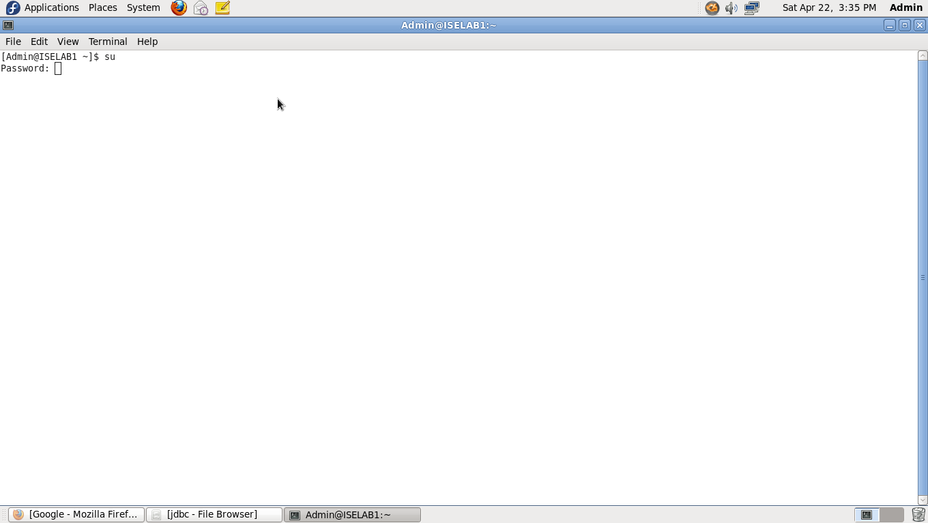

2. service mysqld start

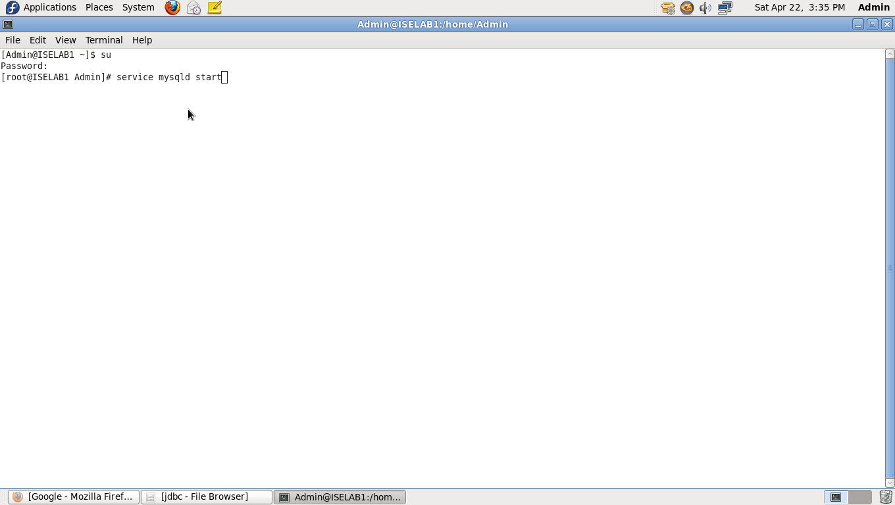

3. mysql –u root

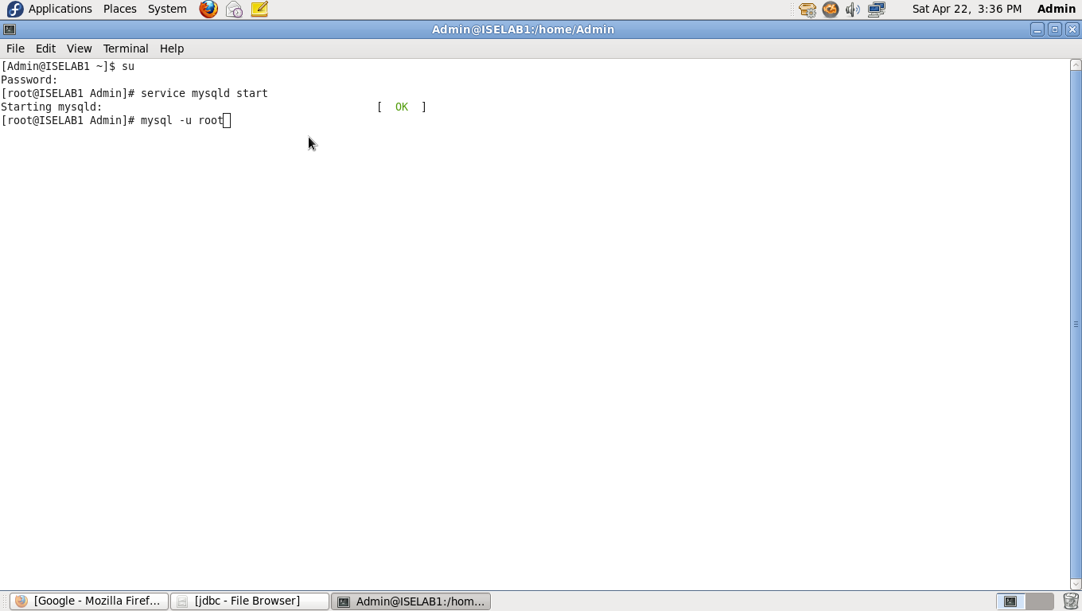

4. mysql> show databases;

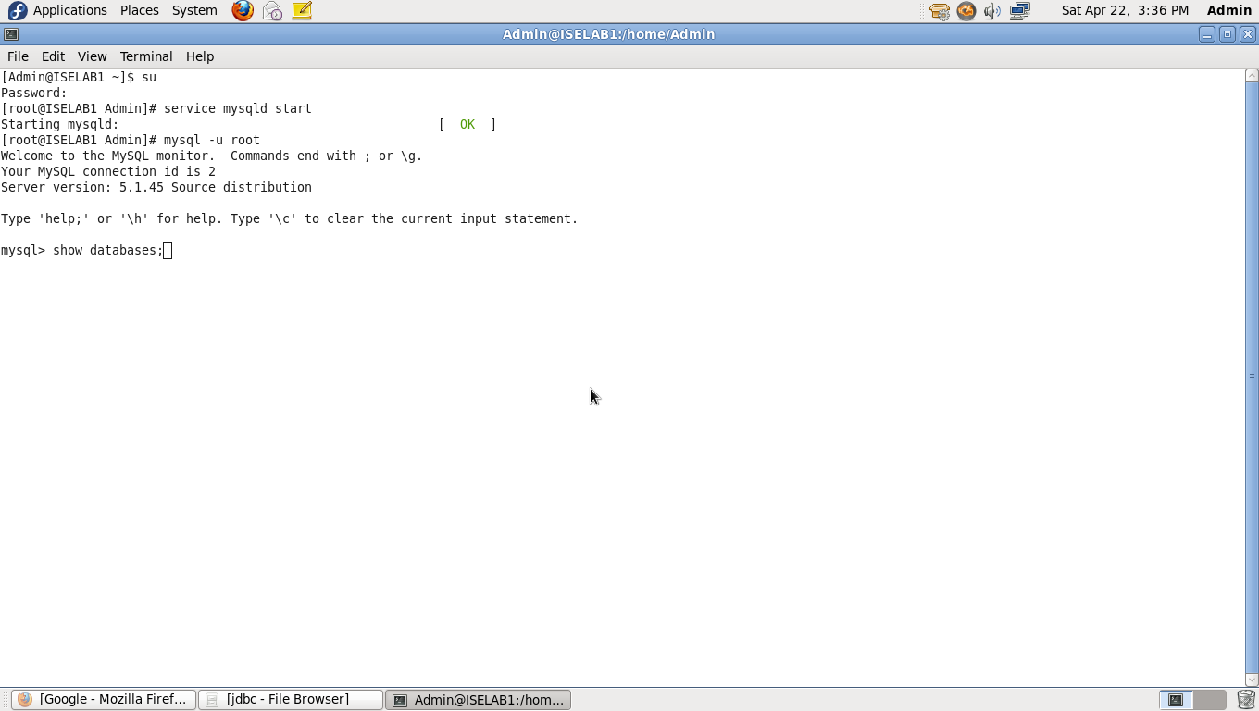

5. mysql> create database databasename;

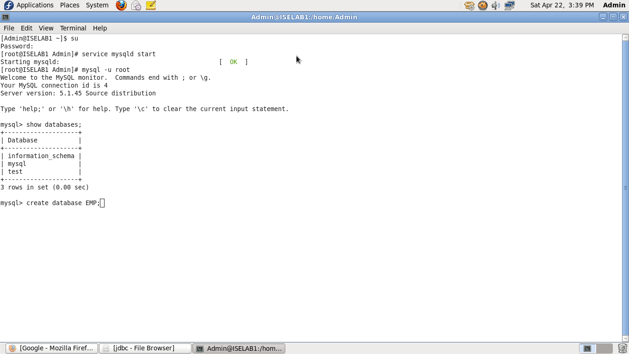

6. mysql> use databasename;

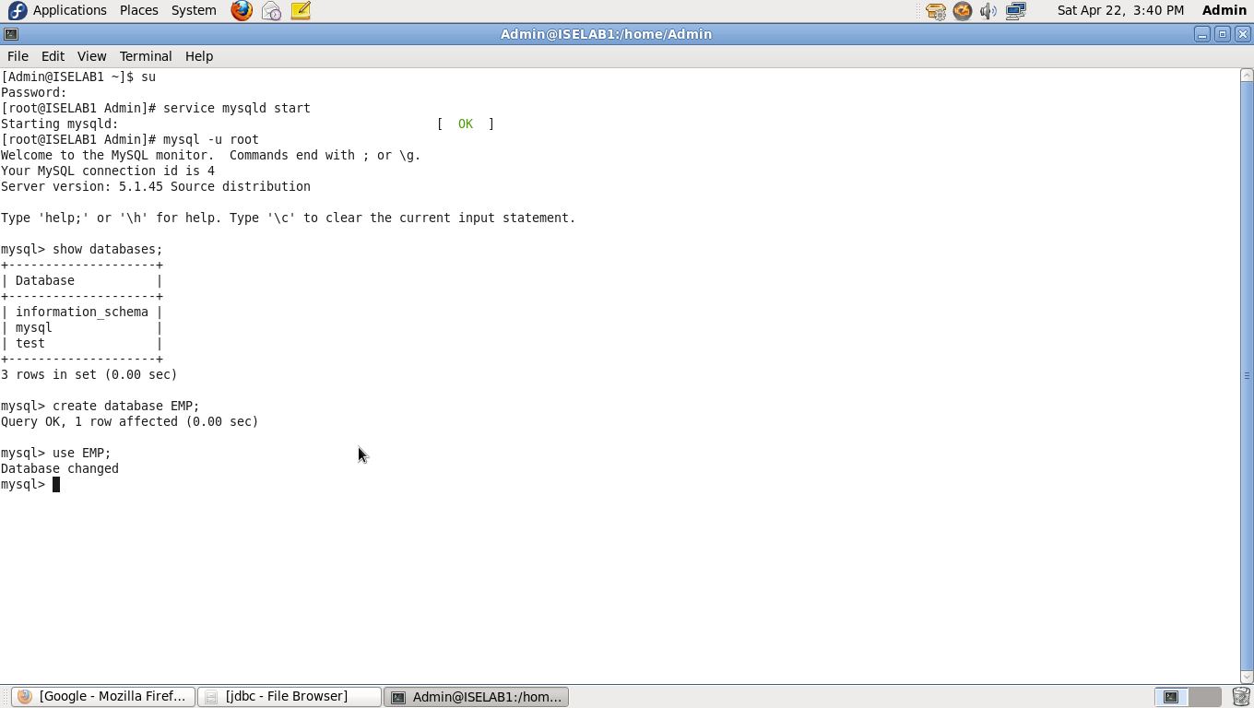

7. mysql> create a table and attributes

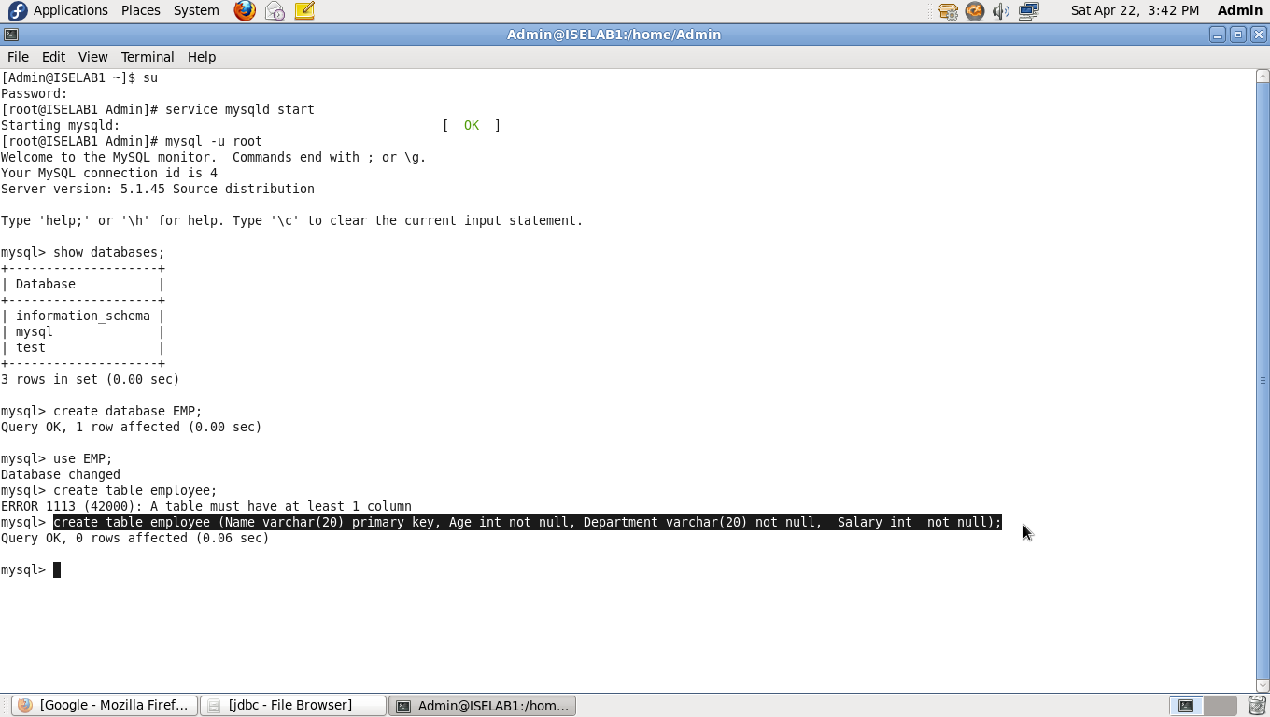

8. mysql> insert table values

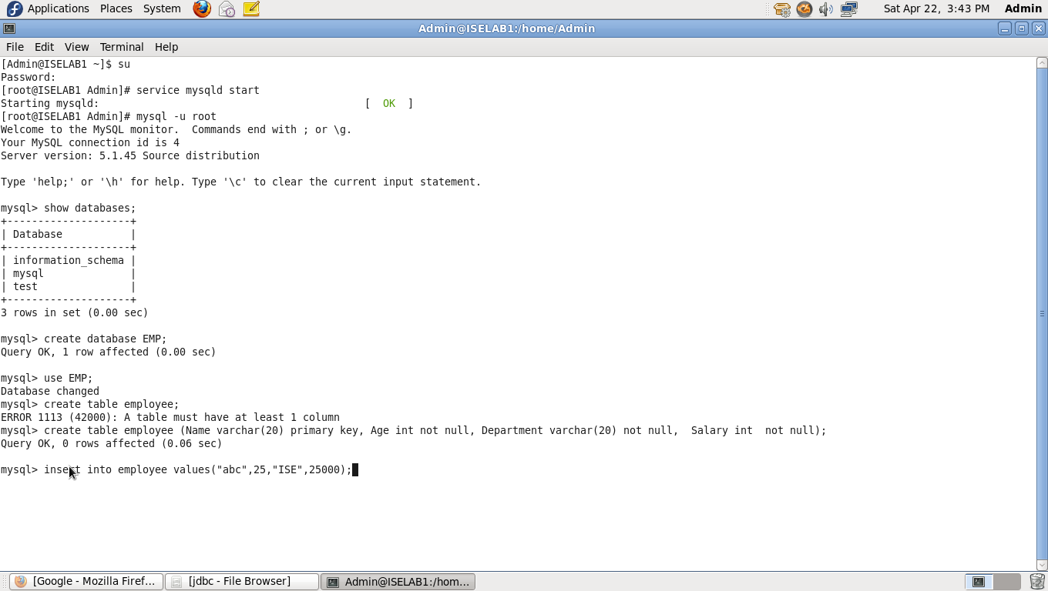

9. Select Table

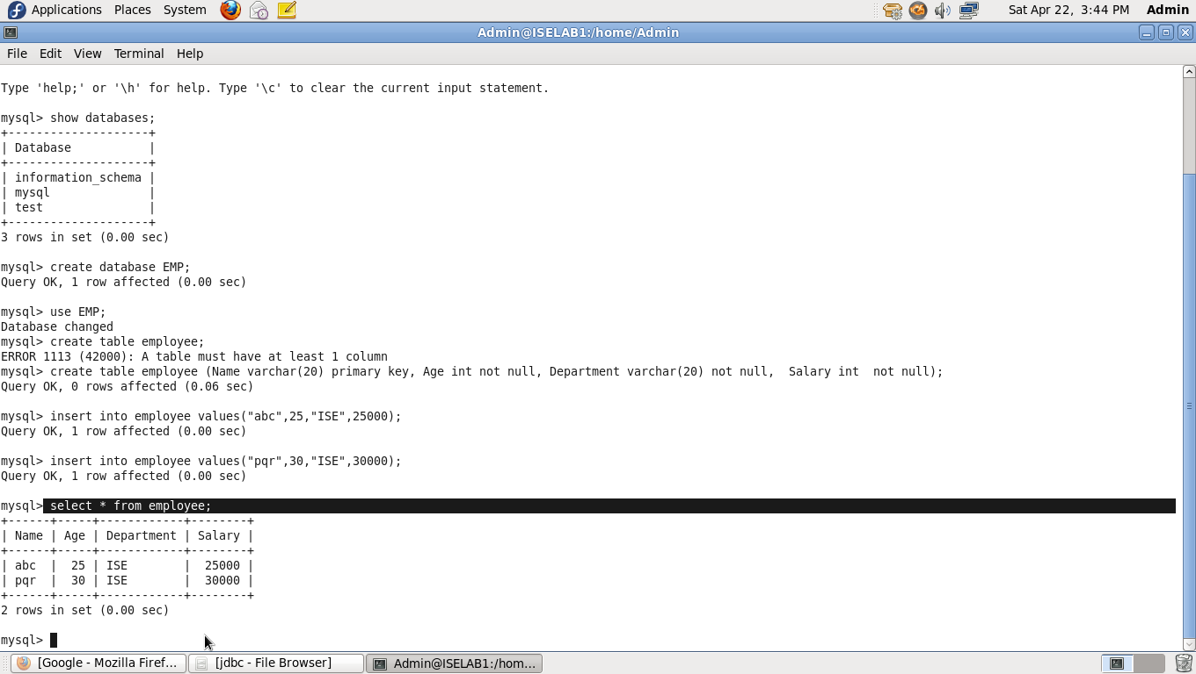

After creating database, minimize the mysql terminal and open eclipse.

Create new java project with any suitable name.

Right click on the project name from the project explorer and navigate to “build path”,

Inside build path sub tab, navigate to “Configure build path” and left click on it.

Select Libraries and click on Add external jars,

Navigate through your file system to usr/share/java/mysql-connector-java-5.1.12.jar. After successful selection, click on Apply followed by click on Ok buttons.

(Note : This step is important, otherwise program will not be able to find the Mysql Driver)

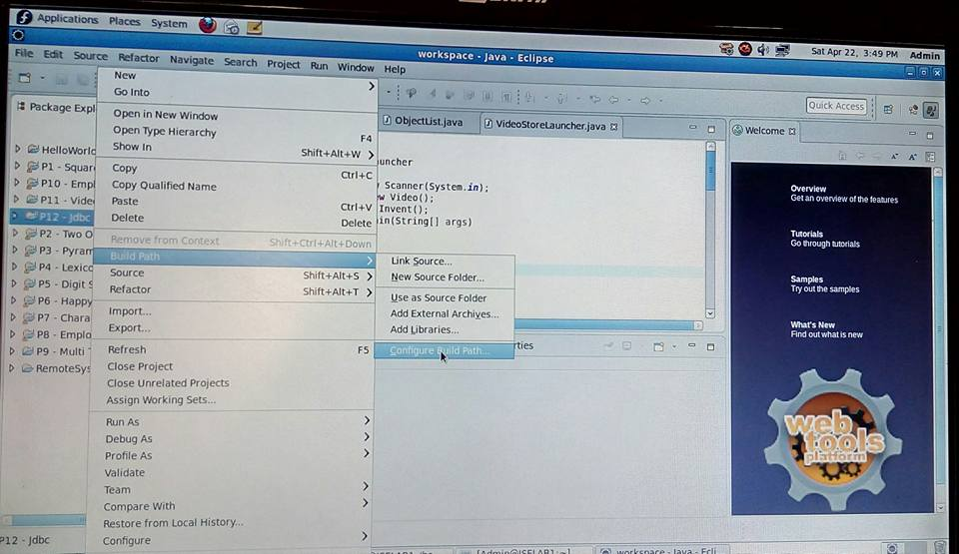

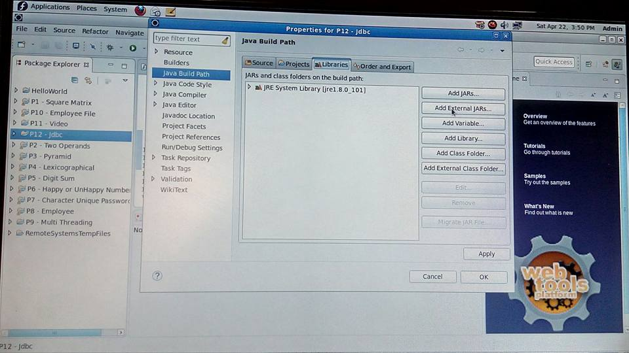

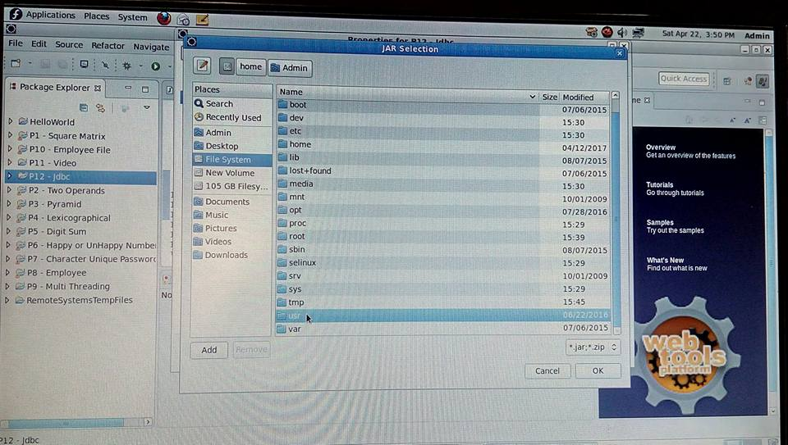

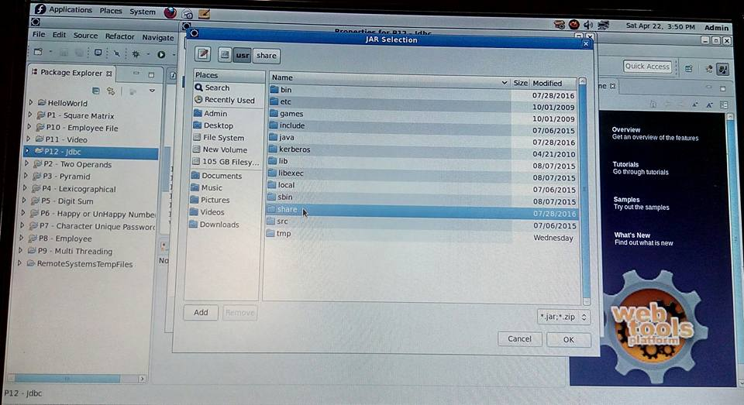

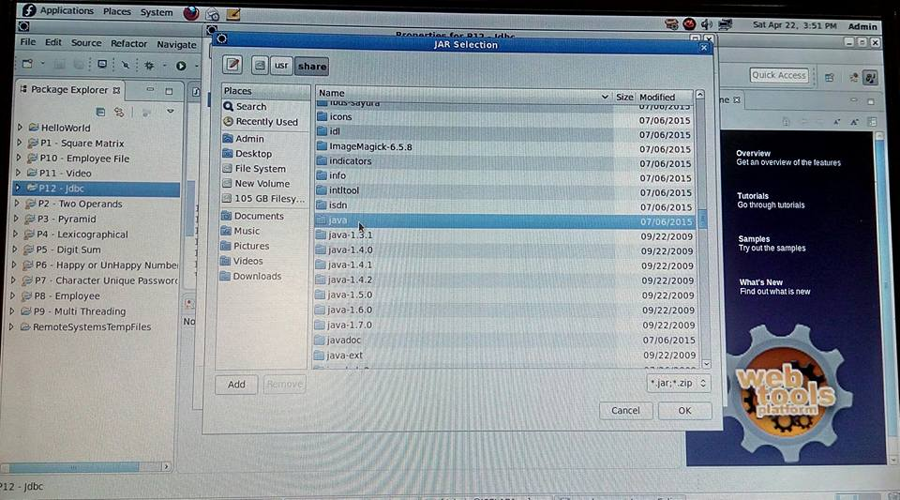

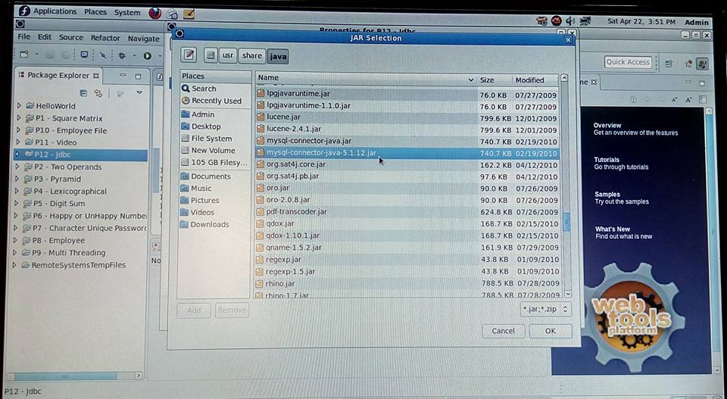

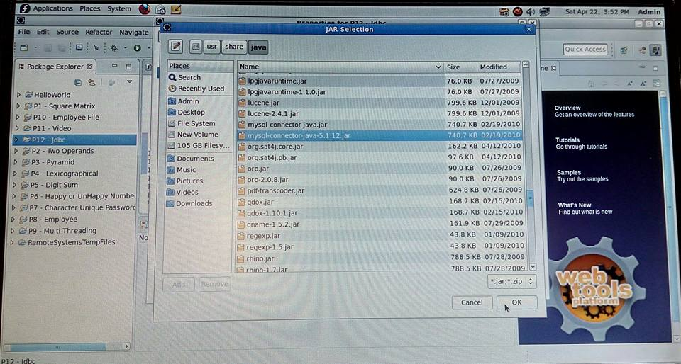

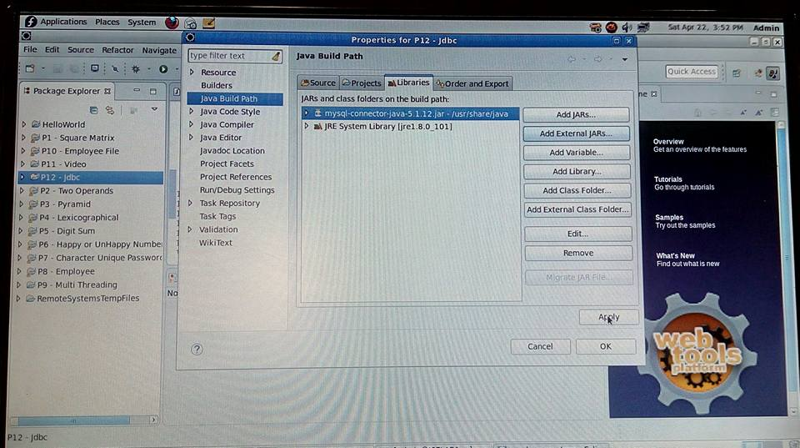

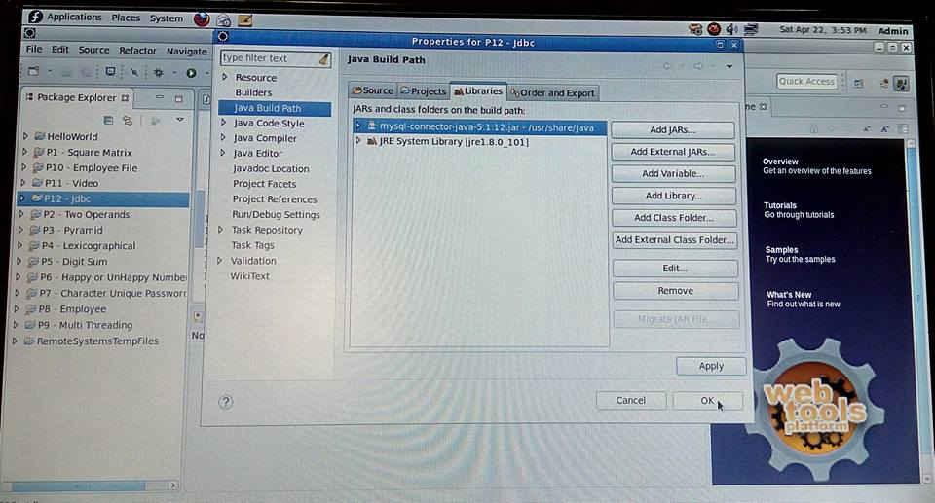

DBConnection.java

import java.sql.Connection;

import java.sql.DriverManager;

import java.sql.SQLException;

public class DBConnection

{

public Connection getDBconnection()

{

Connection conn=null;

try

{

Class.forName("com.mysql.jdbc.Driver");

System.out.println("Registered successfully");

}

catch (ClassNotFoundException e)

{

e.printStackTrace();

}

try

{

conn=DriverManager.getConnection("jdbc:mysql://localhost:3306/EMP","root","");

System.out.println("Connection successfull\n");

}

catch (SQLException e)

{

e.printStackTrace();

}

return conn;

}

}

Employee.java

**public** **class** Employee

{

String name;

**int** age;

String dept;

**double** sal;

**public** String getName()

{

**return** name;

}

**public** **void** setName(String name)

{

**this**.name = name;

}

**public** **int** getAge()

{

**return** age;

}

**public** **void** setAge(**int** age)

{

**this**.age = age;

}

**public** String getDept()

{

**return** dept;

}

**public** **void** setDept(String dept)

{

**this**.dept = dept;

}

**public** **double** getSal()

{

**return** sal;

}

**public** **void** setSal(**double** sal)

{

**this**.sal = sal;

}

}

DAO.java

import java.sql.Connection;

import java.sql.PreparedStatement;

import java.sql.ResultSet;

import java.sql.SQLException;

public class DAO

{

public int insertemp(Employee e)

{

int r=0;

Connection conn=new DBConnection().getDBconnection();

try

{

PreparedStatement pst=conn.prepareStatement("insert into employee values(?,?,?,?)");

pst.setString(1, e.getName());

pst.setInt(2, e.getAge());

pst.setString(3, e.getDept());

pst.setDouble(4, e.getSal());

r=pst.executeUpdate();

}

catch (SQLException e1)

{

e1.printStackTrace();

}

return r;

}

public int deleteemp(String emp)

{

int s=0;

Connection conn=new DBConnection().getDBconnection();

try

{

PreparedStatement pst=conn.prepareStatement("delete from employee where name=?");

pst.setString(1, emp);

s=pst.executeUpdate();

}

catch (SQLException e1)

{

e1.printStackTrace();

}

return s;

}

public void displayname(String ename)

{

Connection conn=new DBConnection().getDBconnection();

try

{

PreparedStatement pst = conn.prepareStatement("select * from employee where name=?");

pst.setString(1, ename);

ResultSet rs=pst.executeQuery();

while(rs.next())

{

System.out.println("Name : " +rs.getString(1)+ "\t"+ "Age : " +rs.getInt(2)+ "\t"+ "Dept :" +rs.getString(3)+ "\t"+ "Salary :" +rs.getDouble(4));;

}

}

catch (SQLException e)

{

e.printStackTrace();

}

}

public void displayall()

{

Connection conn=new DBConnection().getDBconnection();

try

{

PreparedStatement pst=conn.prepareStatement("select * from employee");

ResultSet rs=pst.executeQuery();

while(rs.next())

{

System.out.println("Name : " +rs.getString(1)+ "\t"+ "Age : " +rs.getInt(2)+"\t"+ "Dept :" +rs.getString(3)+"\t" + "Salary :" +rs.getDouble(4));;

}

}

catch (SQLException e1)

{

e1.printStackTrace();

}

}

}

FinalDBProgram.java

**import** java.util.Scanner;

**public** **class** FinalDBProgram

{

**public** **static** **void** main(String[] args)

{

**for**( ; ; )

{

Scanner in=**new** Scanner(System.***in***);

System.***out***.println("\n 1. Insert Emp \n 2. Delete Emp \n 3. Display Acc to Name \n 4. Display All \n 5. Exit \n");

System.***out***.println("Enter your choice");

**int** n=in.nextInt();

Employee e=**new** Employee();

DAO d=**new** DAO();

**switch**(n)

{

**case** 1:

System.***out***.println("Enter the Employee Name : ");

e.setName(in.next());

System.***out***.println("Enter the Age : ");

e.setAge(in.nextInt());

System.***out***.println("Enter the Dept : ");

e.setDept(in.next());

System.***out***.println("Enter the Salary : ");

e.setSal(in.nextDouble());

d.insertemp(e);

System.***out***.println("Employee added successfully");

**break**;

**case** 2:

System.***out***.println("Enter the employee name : ");

String Newname=in.next();

d.deleteemp(Newname);

System.***out***.println("Employee deleeted successfully");

**break**;

**case** 3:System.***out***.println("Enter the Employee name to display its attributes : ");

String ename=in.next();

System.***out***.println("Employee details...");

d.displayname(ename);

**break**;

**case** 4:System.***out***.println("Employee deatils are as follows...");

d.displayall();

**break**;

**case** 5:System.*exit*(0);

**break**;

**default**:

System.***out***.println("Please Choose Valid option \n");

**break**;

}

}

}

}

Console Output

1. Insert Emp

2. Delete Emp

3. Display Acc to Name

4. Display All

5. Exit

Enter your choice

4

Employee deatils are as follows...

Registered successfully

Connection successfull

Name : abc Age : 25 Dept :ISE Salary :25000.0

Name : pqr Age : 30 Dept :ISE Salary :30000.0

1. Insert Emp

2. Delete Emp

3. Display Acc to Name

4. Display All

5. Exit

Enter your choice

1

Enter the Employee Name :

Def

Enter the Age :

28

Enter the Dept :

CSE

Enter the Salary :

26000

Registered successfully

Connection successfull

Employee added successfully

1. Insert Emp

2. Delete Emp

3. Display Acc to Name

4. Display All

5. Exit

Enter your choice

4

Employee deatils are as follows...

Registered successfully

Connection successfull

Name : abc Age : 25 Dept :ISE Salary :25000.0

Name : pqr Age : 30 Dept :ISE Salary :30000.0

Name : Def Age : 28 Dept :CSE Salary :26000.0

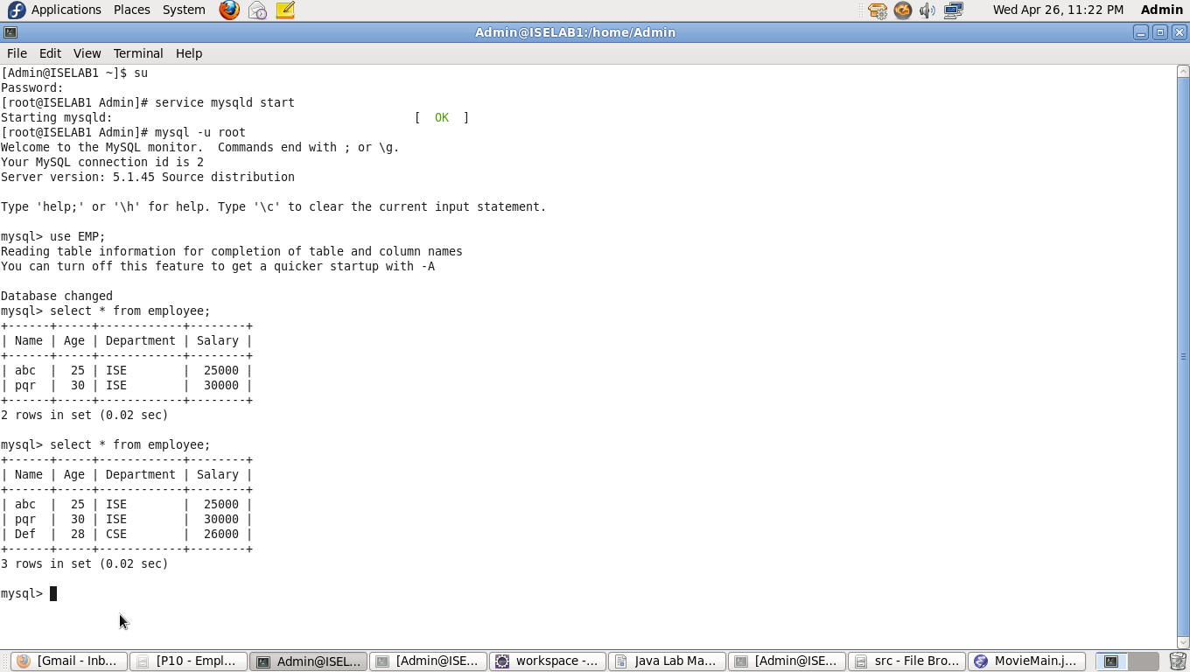

1. Insert Emp

2. Delete Emp

3. Display Acc to Name

4. Display All

5. Exit

Enter your choice

3

Enter the Employee name to display its attributes :

Abc

Employee details...

Registered successfully

Connection successfull

Name : abc Age : 25 Dept :ISE Salary :25000.0

1. Insert Emp

2. Delete Emp

3. Display Acc to Name

4. Display All

5. Exit

Enter your choice

2

Enter the employee name :

Abc

Registered successfully

Connection successfull

Employee deleeted successfully

1. Insert Emp

2. Delete Emp

3. Display Acc to Name

4. Display All

5. Exit

Enter your choice

4

Employee deatils are as follows...

Registered successfully

Connection successfull

Name : pqr Age : 30 Dept :ISE Salary :30000.0

Name : Def Age : 28 Dept :CSE Salary :26000.0

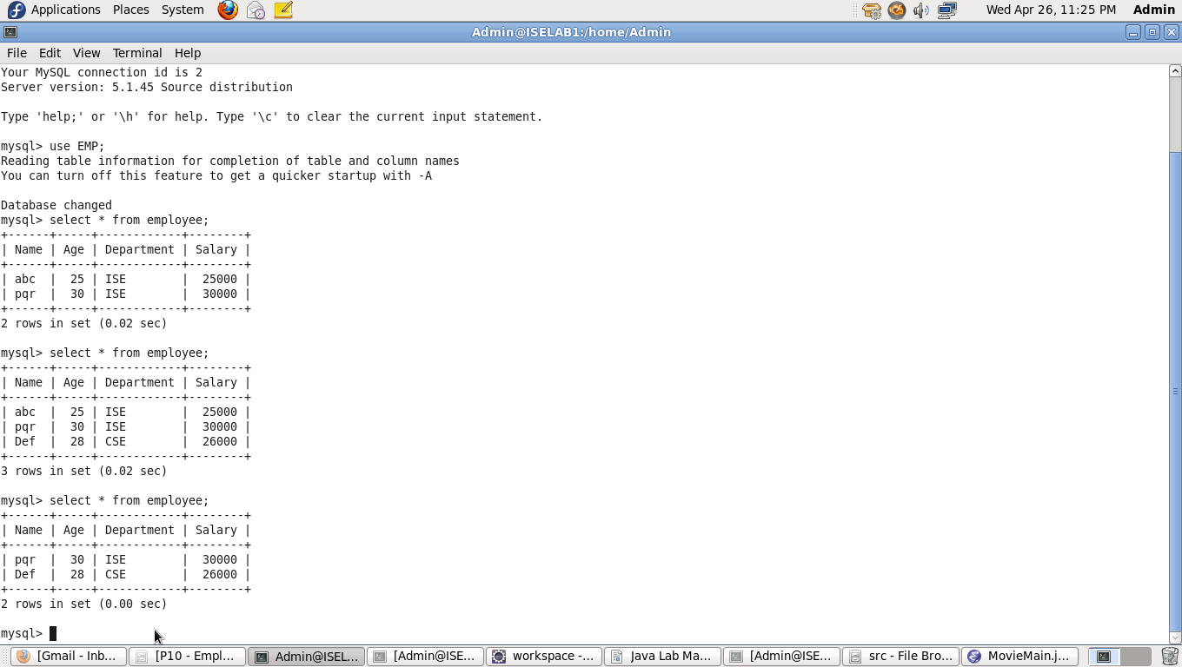

1. Insert Emp

2. Delete Emp

3. Display Acc to Name

4. Display All

5. Exit

Enter your choice

5